M960 Screen Tester
Product Manual
V1.0
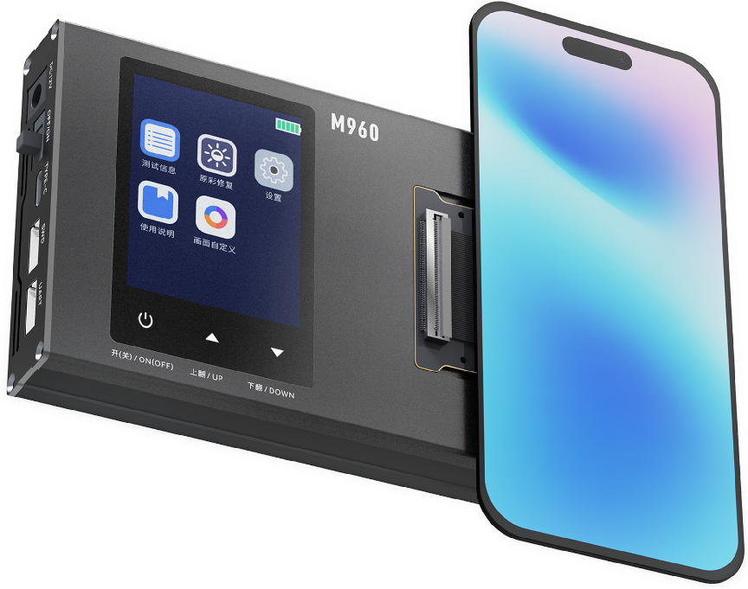

Shenzhen Yuchengxing Electronics Technology Co., Ltd.
Address: 3F, Building 4, Rihai Intelligent Technology Park, Longhua District, Shenzhen, China
Service Hotline: +86-755-23221950
Note: Images are for illustrative purposes only. Actual product appearance may vary.

Table of Contents

1.1Product Advantages....................................................4

1.2Main Function Menu Description...............................5

2.1Button Functions.........................................................7

2.2Flex Cable Connection Diagram.................................8

3.M960 Tester Power On/Off............................................9

4.Screen Display Testing..................................................11

5.Touch Line Drawing Test..............................................13

6.Brightness Cycle............................................................14

7.True Color Restoration..................................................15

8.APP Upgrade..................................................................16

9.Product Specifications & Packaging........................... 18

10.Warranty & Non-Warranty Terms...............................19

11.Usage Precautions......................................................20

1.1 Product Advantages：
1.Multi-Interface Compatibility
Supports eDP (ALP-DP), MIPI, and QSPI interfaces, enabling full-speed eDP signal display output.
2.Universal Screen Compatibility
Compatible with displayand touch testing for OLED, TFT, Original (OEM), Aftermarket, and Compressed screens.
3.Real-Time Power Monitoring
Built-in voltage/current acquisition module for real-time screen power consumption tracking.
4.Multi-Layer Circuit Protection
Integrated multi-stage over-current (OCP) and over-voltage (OVP) protection within the test box.
5.Custom Display Configuration
Supports user-defined screen content (static images/dynamic videos).
6.Apple True Tone Restoration
Enables True Tone display calibration and color temperature recovery for Apple devices.
7.Firmware Upgradable via App
Supports wireless OTA (Over-The-Air) updates for test protocols and software versions.
8.Brightness Cycle Testing
9.Refresh Rate Verification
Tests dynamic refresh rates (e.g., 60Hz/90Hz/120Hz) and detects frame rate jitter.
10.LCD Driver IC Identification
Automatically reads LCD driver IC models.
11.The screen test models are complete and the update speed is fast.

1.2Product Main Function Menu Description：
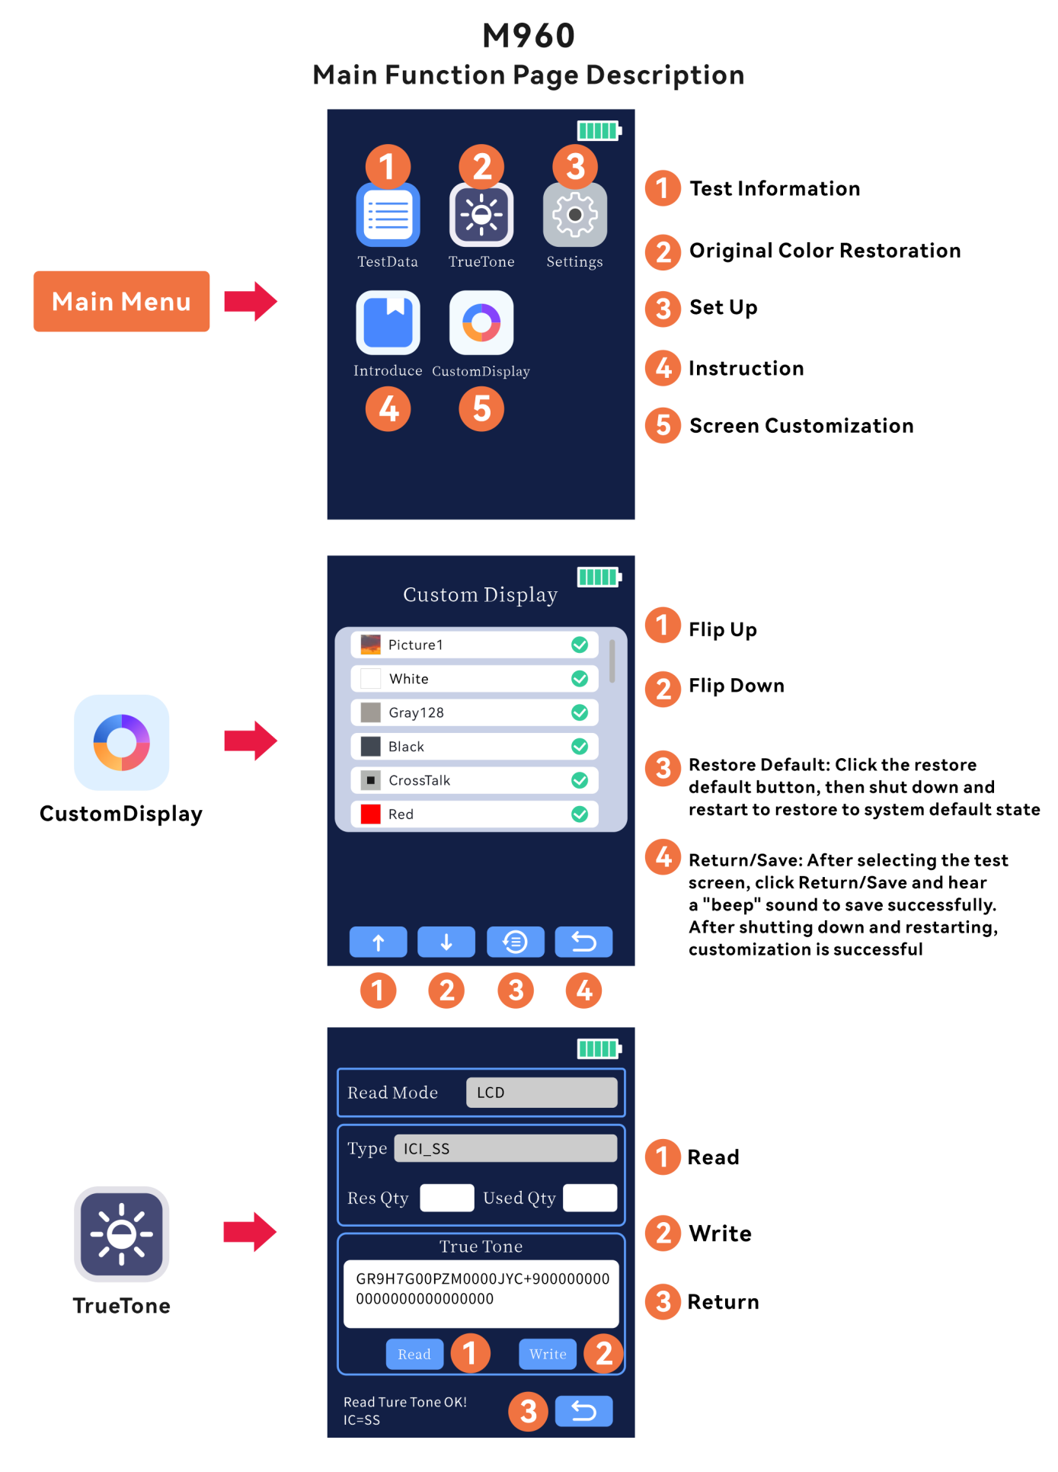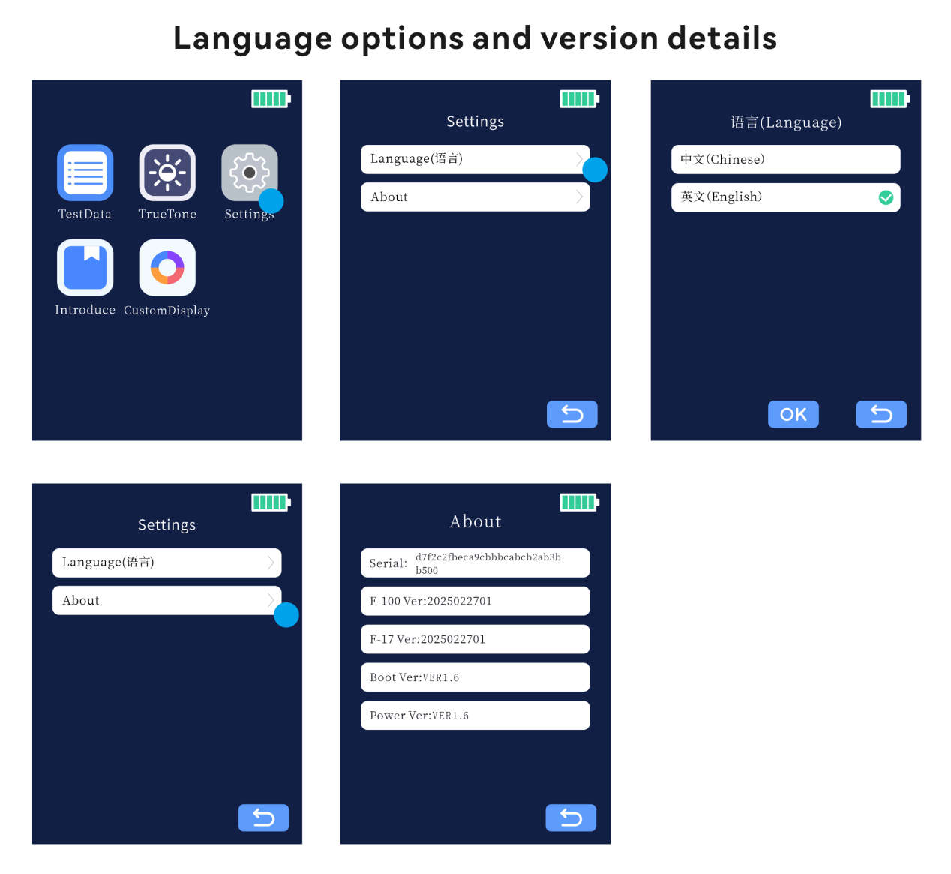

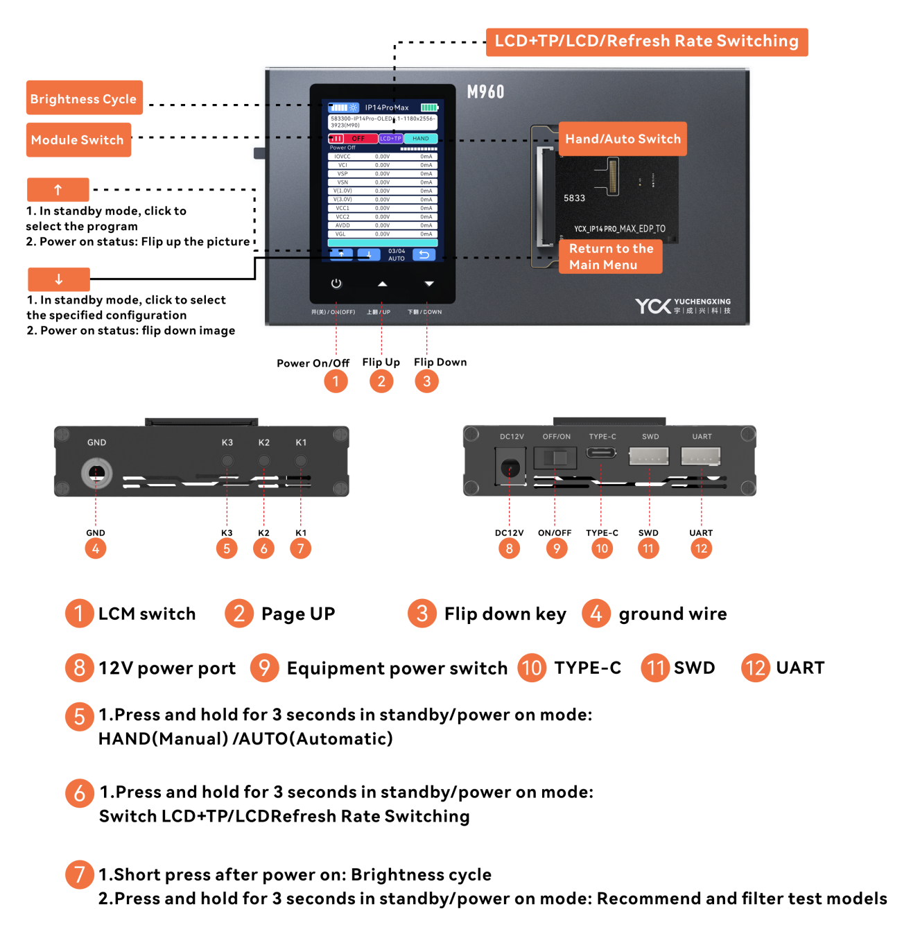
2.1Button Functions：
K1 Button
Short press when powered: Cycles through brightness levels.
Long press (3 seconds) in any state: Initiates model recommendation and filter testing.
K2 Button
Long press (3 seconds) in standby or powered state: Switches between LCD+TP, LCD-only, or refresh rate modes.
K3 Button
Long press (3 seconds) in standby or powered state: Switches between HAND (Manual) and AUTO (Automatic) modes.
Up Button
Short press in standby: Powers on the device.
Short press when powered: Cycles backward through display images.
Down Button
Short press in standby: Powers on the device.
Auto Shutdown
Powers off automatically after 10 minutes of inactivity in standby mode.
2.2 Schematic diagram of cable connection：

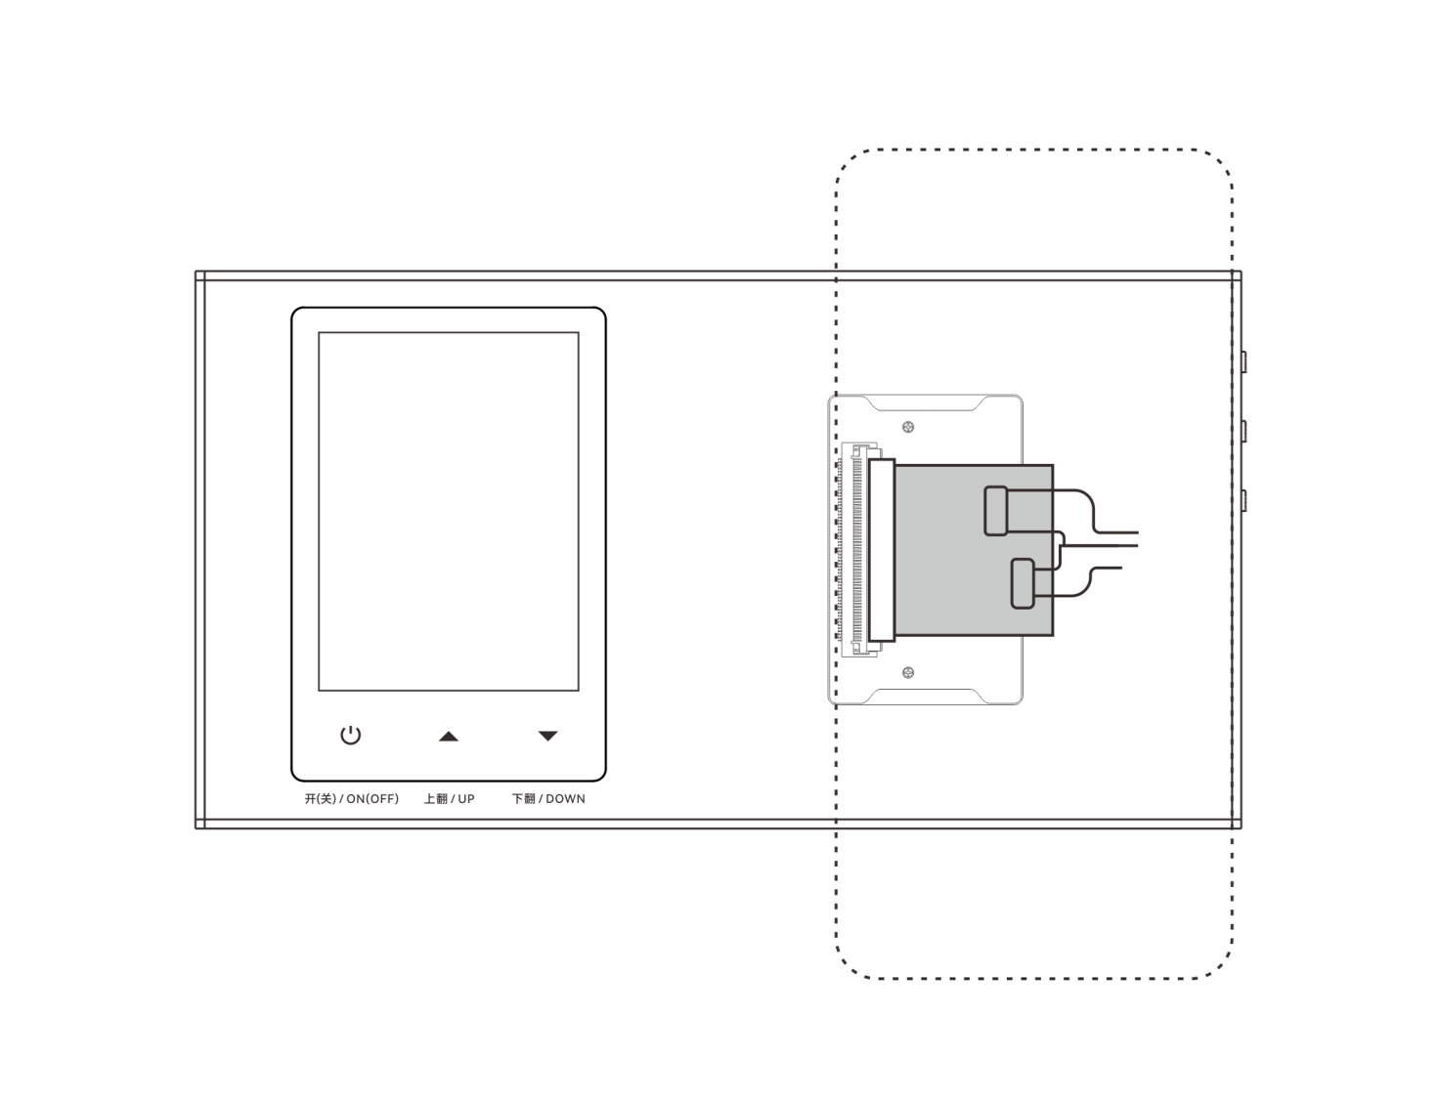

3 M960 test box on/off
Power on: Plug in the DC power cord and switch the "Power Switch" to the "ON" state to turn on the power of the M960 test box.
After the built-in screen of the test box lights up and works normally, it can be successfully turned on.
Shutdown: Switch the "Power Switch" to the "OFF" state to turn off the power of the M960 test box. Simply unplug the power cord.

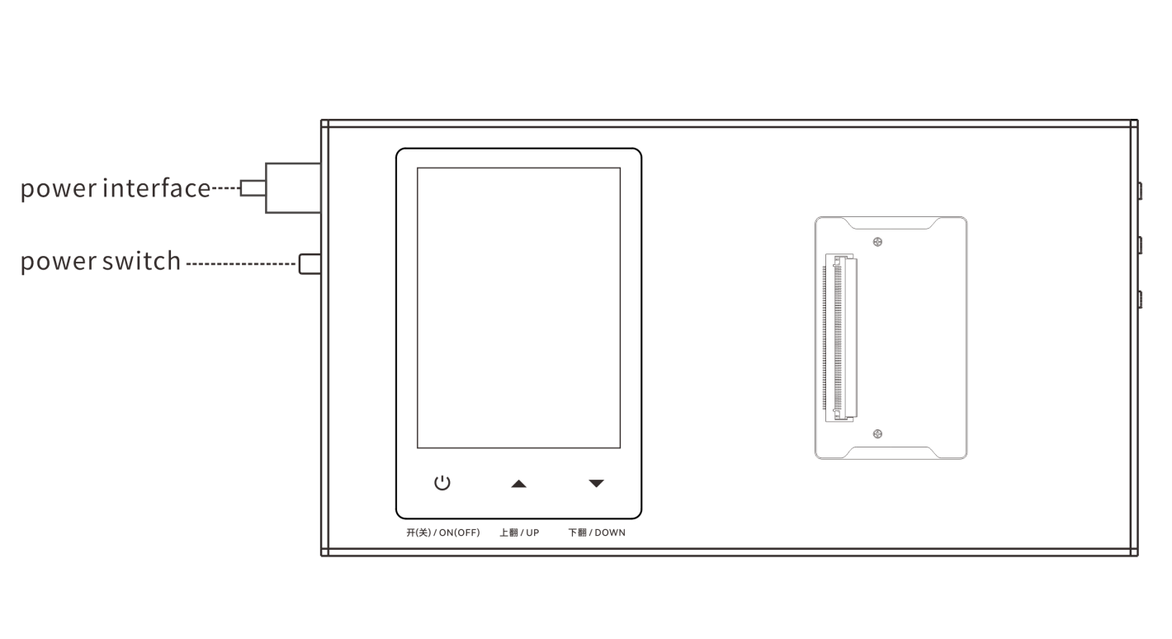

4 Screen Display Testing Procedure
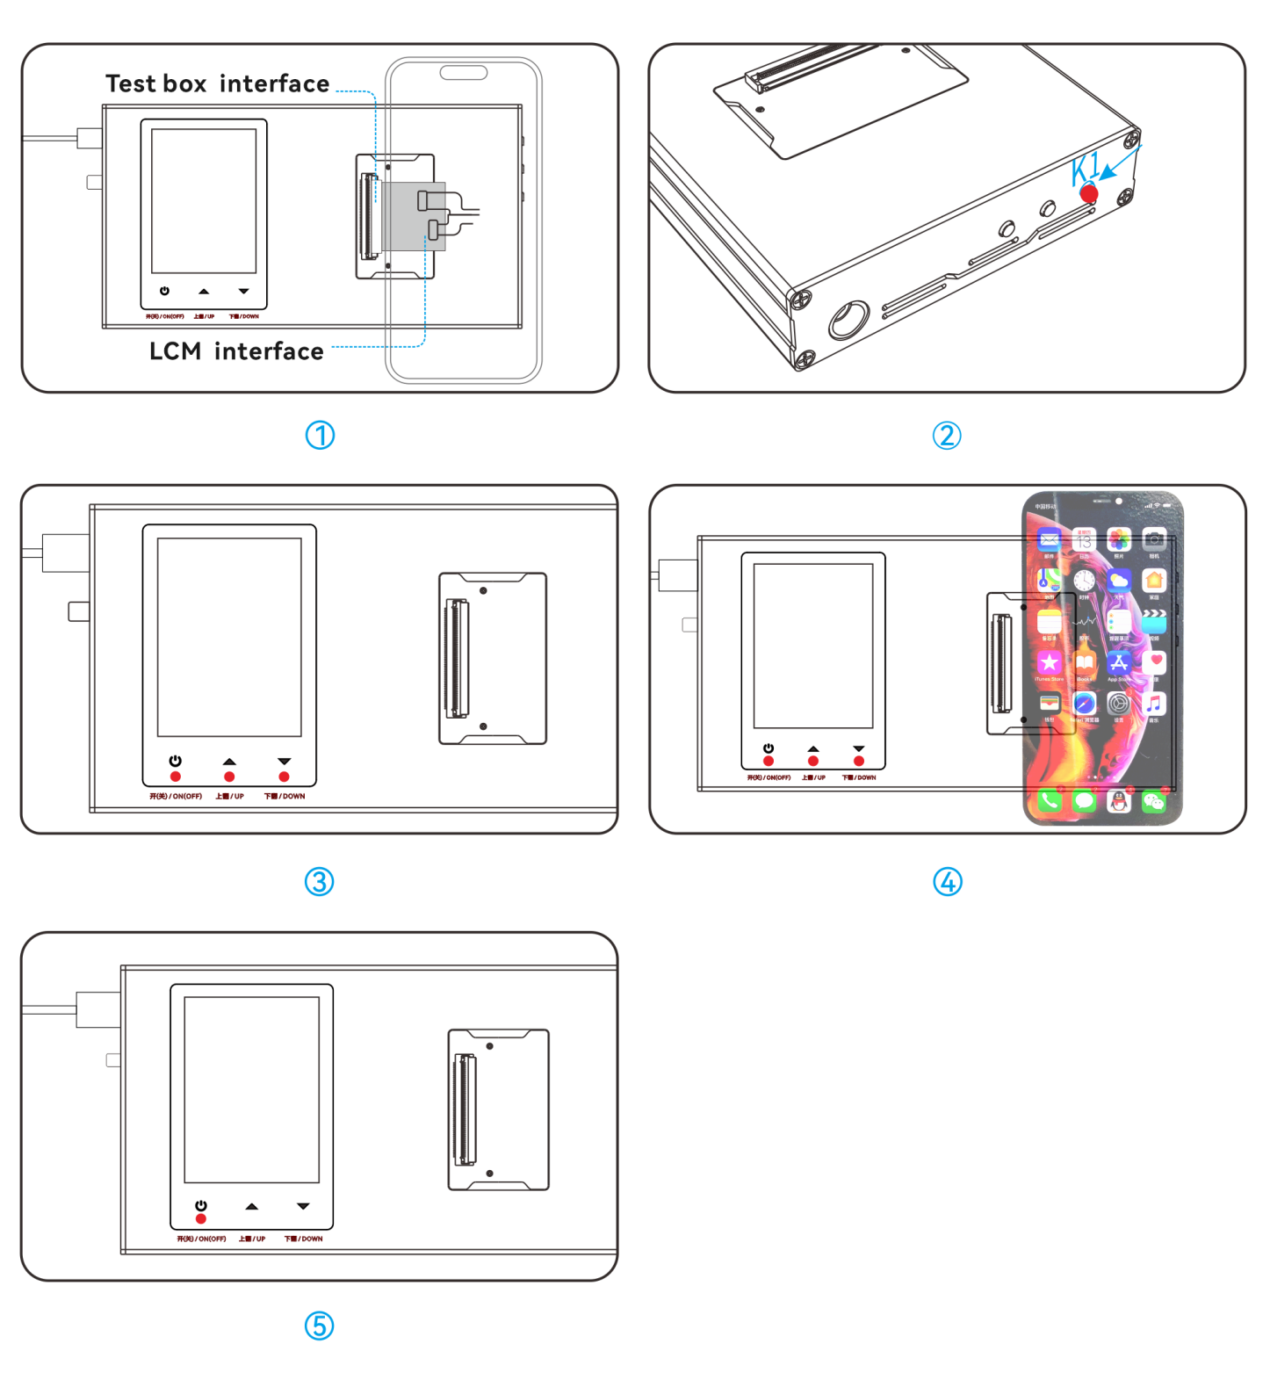
Step 1: Preparation before testing: The "test screen" corresponds to the adapter board and adapter cable (eDP adapter board needs to be connected to the cable with eDP letters written on it)
Step 2: Close the screen, click the power button, and click "Flip Up, Flip Down" to switch to the test screen and view the effect.
Step 3: Turn off the screen, click on the "power button" to turn off the screen.
Step 4: Repeat the above steps to continue testing the next screen
Note: Switching program: When the screen is not powered on, click the up button icon on the small screen to switch

5 Touch Line Drawing Test
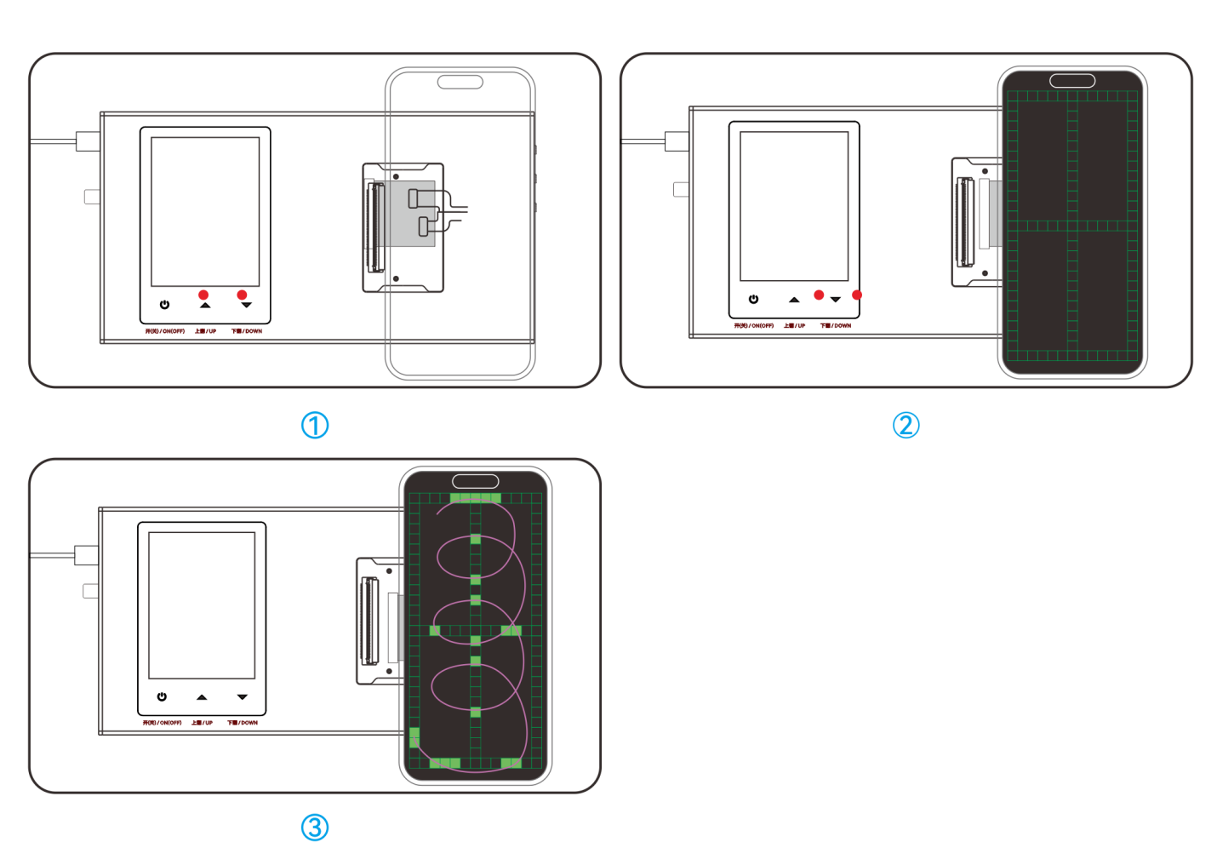
Step 1: After the "test screen" lights up, click "flip up, flip down" to switch to the touch line test interface normally
Step 2: Finger marking test screen function

6 Brightness Cycle Function
Step 1: Tap the Brightness Cycle icon in the top-right corner of the screen or press the K1 button to activate brightness cycling.
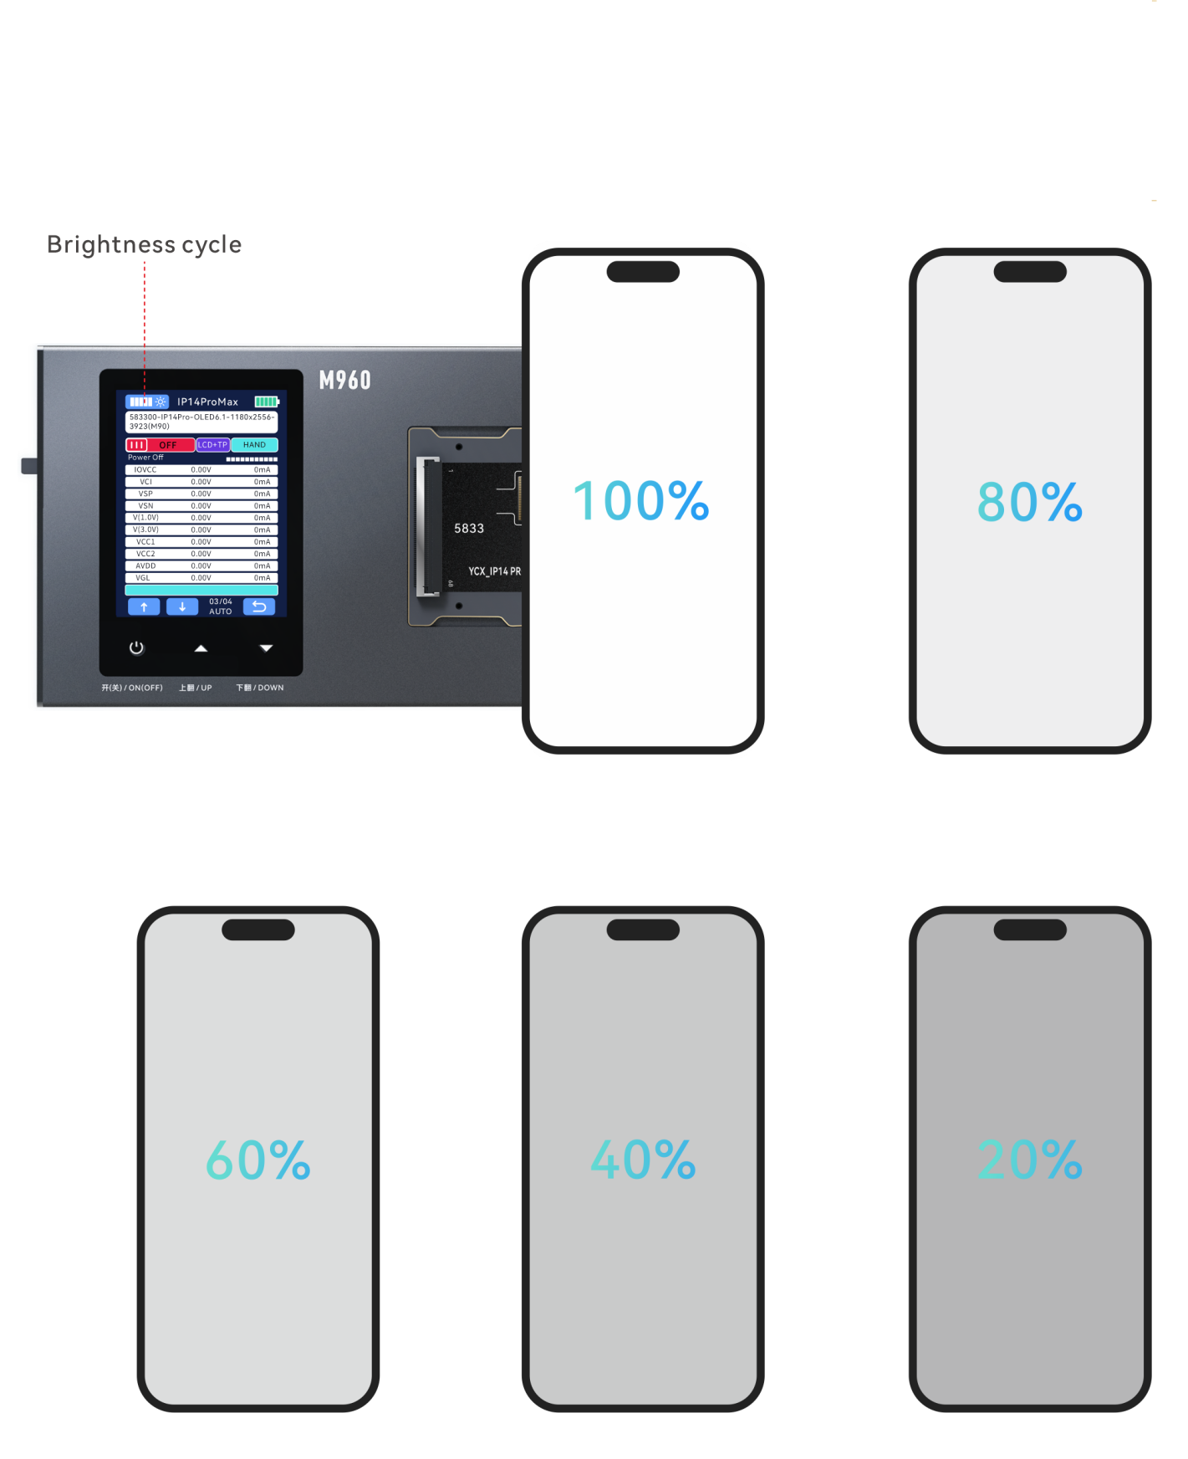
7 Screen True Color Restoration
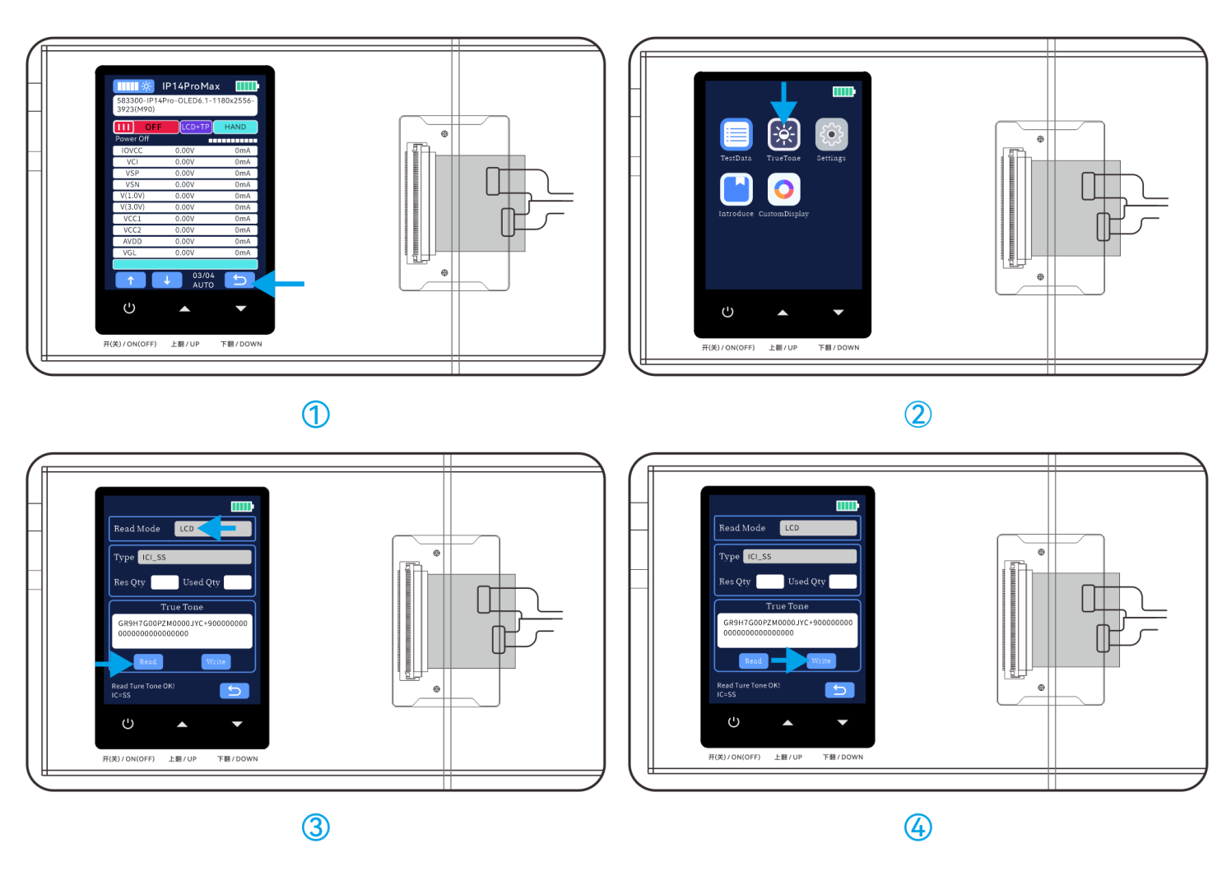
Step 1: Hardware Connection
Mount the screen to the corresponding adapter board and flex cable.
After the system recognizes the connected device, press the Back button to return to the Main Menu.

Step 2: Initiate True Color Restoration
Tap the True Color Restoration icon on the interface.

Step 3: Select Read Mode
Read Mode Options:
LCD: Direct read via display interface.
I2C: Read through I²C protocol.
PC: Requires connection to a host computer (software-controlled).
Switch Modes: Use the Up/Down buttons to toggle between modes.
Execute Read Operation:
Mount the source screen (the screen containing original color data).
Click the Read button.
Upon success, the message "Read Original Color OK!" will appear at the bottom of the screen.

Step 4: Write Original Color Data
Prepare Target Screen:
Remove the source screen and mount the target screen (the screen to be calibrated).
Click the Write button.
Completion Confirmation:
A success message "Write Original Color OK!" will display at the screen bottom.

8 APP Online Update Function
Yuchengxing Assistant APP Online Upgrade: Get Installation Package
1. Log in to the Chinese website of Yuchengxing and download: http://www.ycxbest.com/M960.html
English website：www.ycxbest.com/en/M960.html
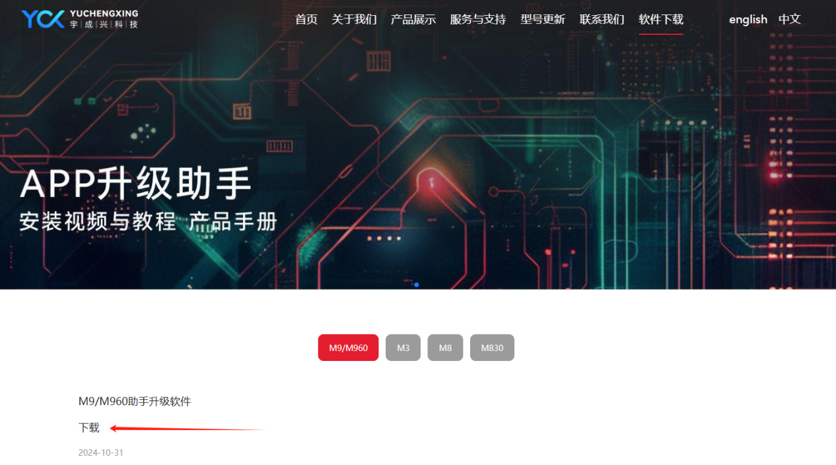
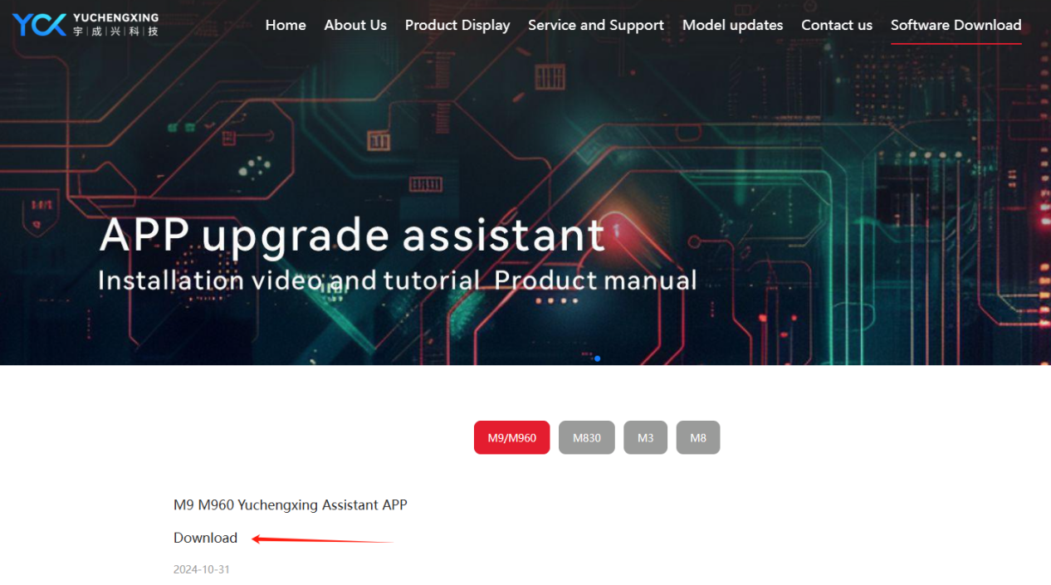

Update Procedure
After installation, log in to the APP.
Power on the device and connect it to a computer to initiate the firmware update.
Note: For detailed instructions, download the installation manual and video guides.

9 Product Specifications & Packaging
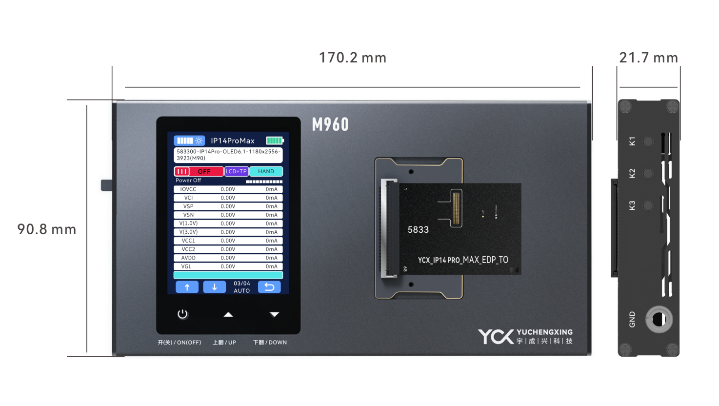
Product Parameters：
Model: M960
Material: Aluminum Alloy
Color: Dark Gray
Power Supply: DC12V—1.5A
Power Interface: DC interface
Operating Temperature: 25℃ to 85℃
Operating Humidity: <90% RH
Dimensions: 170mm × 90.8mm × 21.7mm
M960 bare machine weight: 285g ± 10g
Storage Conditions: -30℃ to 85℃, <90% RH

Package Contents：M960 Screen Tester、 DC charging cable
Packaging Details

10 Warranty & Non-Warranty Terms
Warranty Coverage：
- 7-Day Policy
Within 7 days from the date of receipt, if the product exhibits performance failures confirmed by our after-sales service center, you are entitled to free return, replacement, or repair.
2.8-15 Day Policy
Between 8-15 days from the date of receipt, confirmed performance failures qualify for free replacement or repair.
3.1-Year Limited Warranty
Within 1 year from the date of receipt, confirmed performance failures qualify for free repair services.
- Non-Warranty Cases: 4.1. Damage caused by unauthorized disassembly, repair, misuse, modification, or improper storage. 4.2.Use of non-original accessories or tampering with product labels (e.g., tearing, altering).
4.3.Products exceeding the warranty period.
4.4.Damage due to natural disasters or force majeure.
4.5. Damage caused by using non-compliant chargers (exceeding specified voltage ratings).
5.*Final Interpretation Rights
Yuchengxing Electronics Technology Co., Ltd. reserves the right to interpret these terms within legal limits.

11 Usage Precautions
Power Supply
Ensure the power supply voltage matches the device's rated voltage before connecting to the testing box.
Use original manufacturer-provided charging cables.
Additional Guidelines：
1.Environmental Conditions
Avoid using the device in high-temperature or humid environments to prevent reduced lifespan or damage.
2.Interface Compliance
Input/output ports are clearly labeled. Ensure correct connections during operation.
3.Tampering Prohibition
Do not disassemble the device, as this may cause damage or compromise testing accuracy.
4.Maintenance
Regularly clean accumulated dust and debris to maintain device hygiene.
5.Mechanical Stress
Protect the device from mechanical shocks or impacts.

