M9 Screen Tester
Product Manual
V1.0
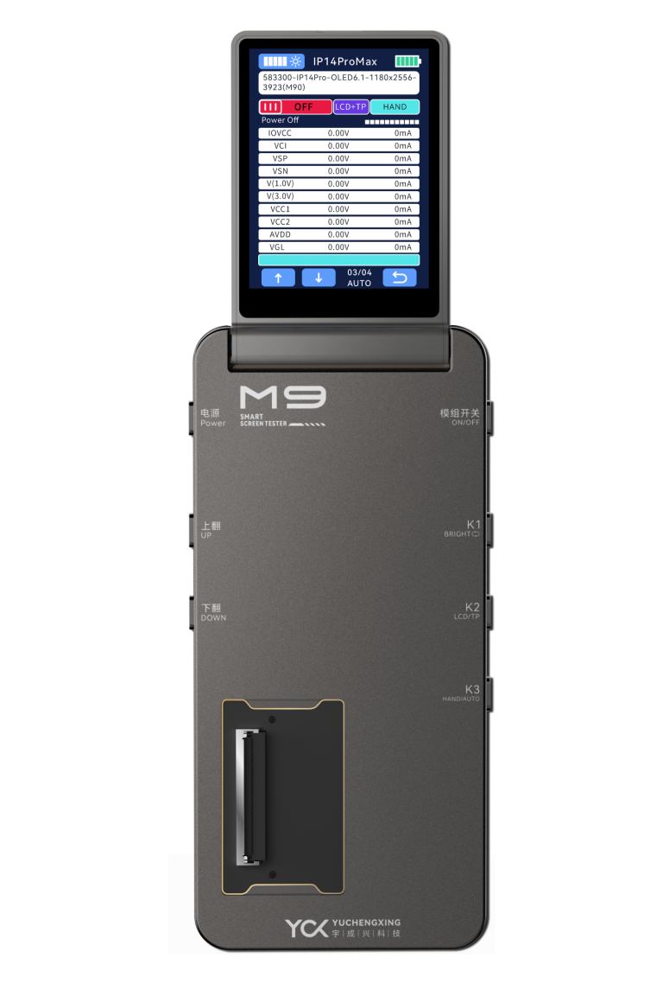


Shenzhen Yuchengxing Electronics Technology Co., Ltd.
Address: 3F, Building 4, Rihai Intelligent Technology Park, Longhua District, Shenzhen, China
Service Hotline: +86-755-23221950
Note: Images are for illustrative purposes only. Actual product appearance may vary.

Table of Contents

1.1Product Advantages....................................................4

1.2Main Function Menu Description...............................5

2.1Button Functions.........................................................7

2.2Flex Cable Connection Diagram.................................8

3.M9 Tester Power On/Off................................................9

4.Screen Display Testing..................................................11

5.Touch Line Drawing Test..............................................13

6.Brightness Cycle............................................................14

7.True Color Restoration..................................................15

8.APP Upgrade..................................................................16

9.Product Specifications & Packaging........................... 18

10.Warranty & Non-Warranty Terms...............................19

11.Usage Precautions......................................................20

1.1 Product Advantages：
1.Multi-Interface Compatibility
Supports eDP (ALP-DP), MIPI, and QSPI interfaces, enabling full-speed eDP signal display output.
- Universal Screen Compatibility
Compatible with displayand touch testing for OLED, TFT, Original (OEM), Aftermarket, and Compressed screens.
- Modular Battery Design
Features replaceable batteries (Model: IP11) for extended operational uptime.
- Real-Time Power Monitoring
Built-in voltage/current acquisition module for real-time screen power consumption tracking.
- Multi-Layer Circuit Protection
Integrated multi-stage over-current (OCP) and over-voltage (OVP) protection within the test box.
- Custom Display Configuration
Supports user-defined screen content (static images/dynamic videos).
- Apple True Tone Restoration
Enables True Tone display calibration and color temperature recovery for Apple devices.
- Firmware Upgradable via App
Supports wireless OTA (Over-The-Air) updates for test protocols and software versions.
9.Brightness Cycle Testing
10.Refresh Rate Verification
Tests dynamic refresh rates (e.g., 60Hz/90Hz/120Hz) and detects frame rate jitter.
11.LCD Driver IC Identification
Automatically reads LCD driver IC models.
12.The screen test models are complete and the update speed is fast.

1.2Product Main Function Menu Description：
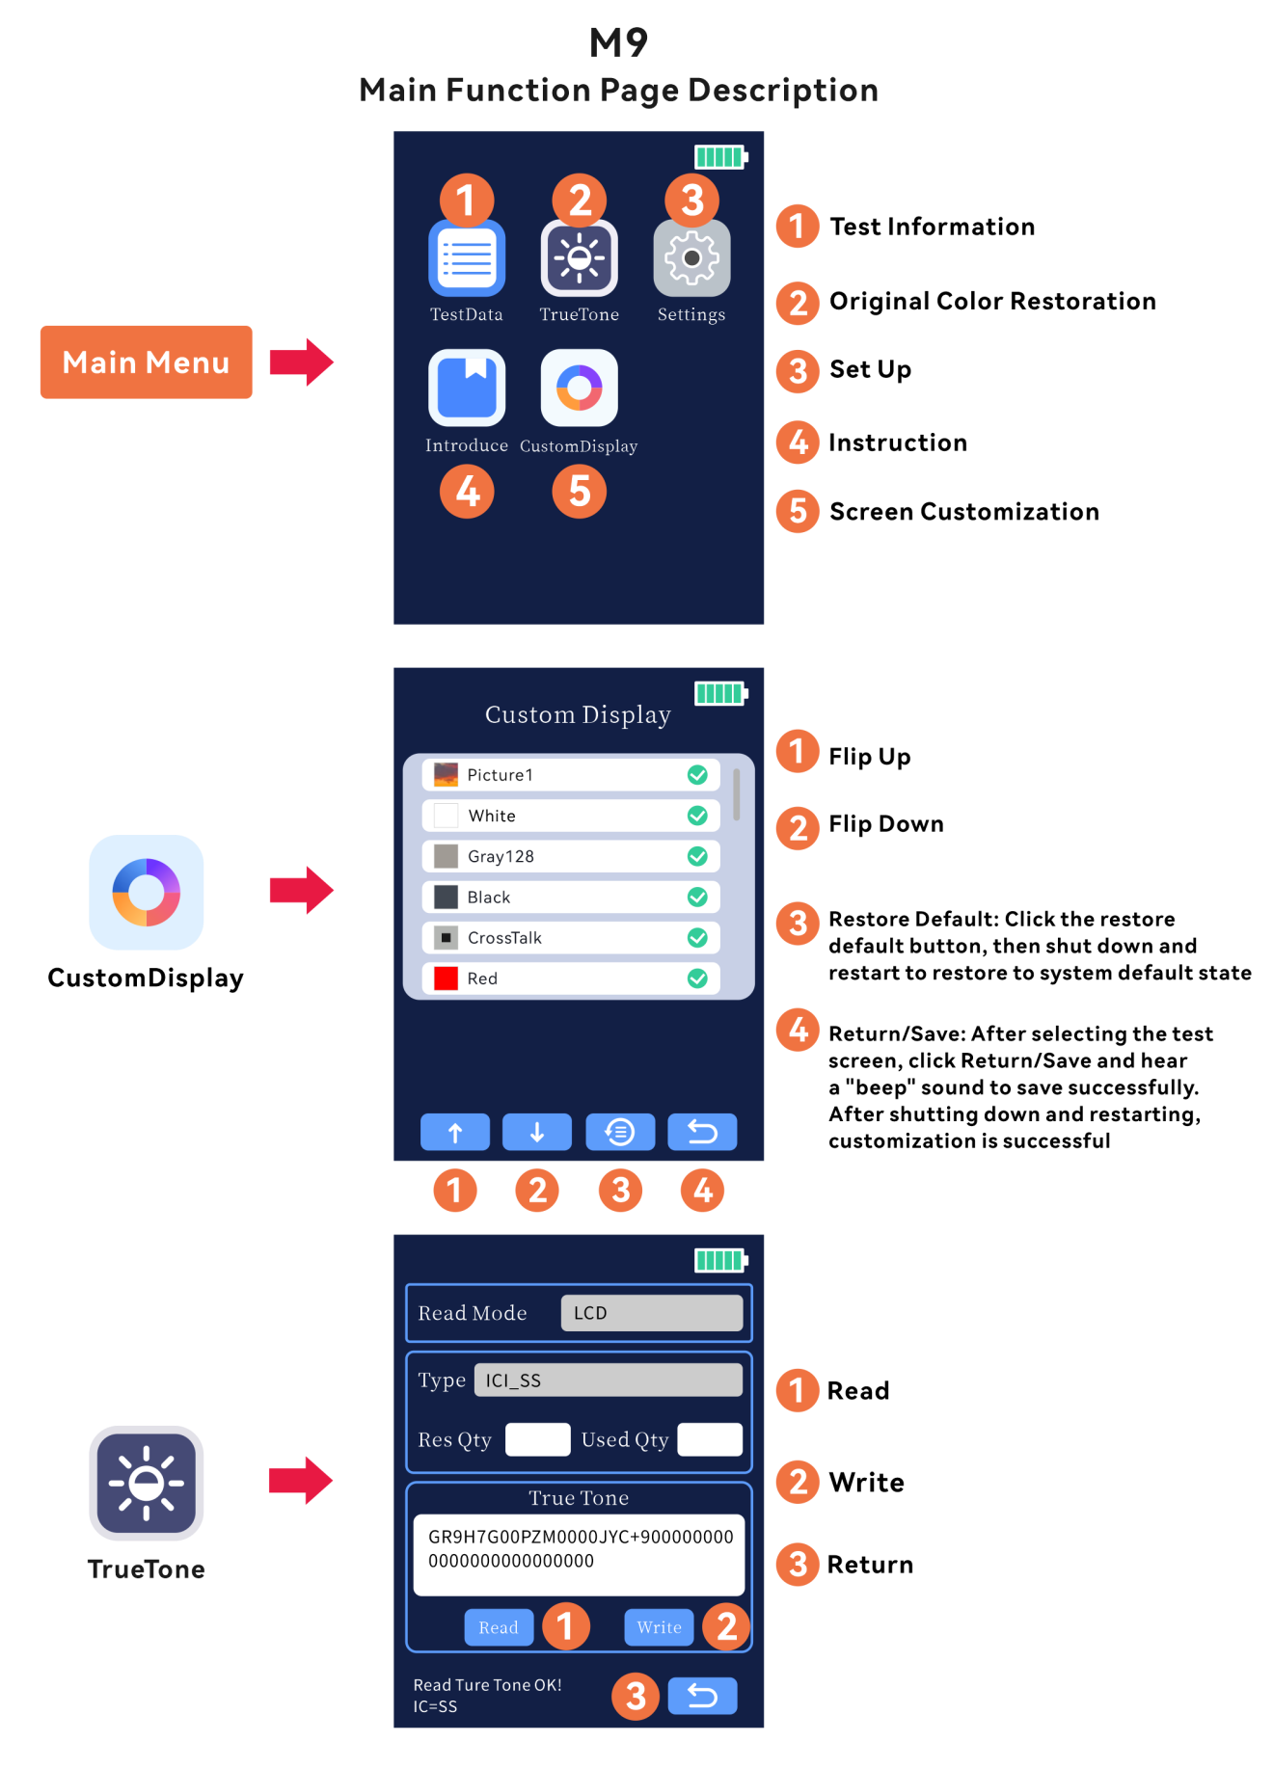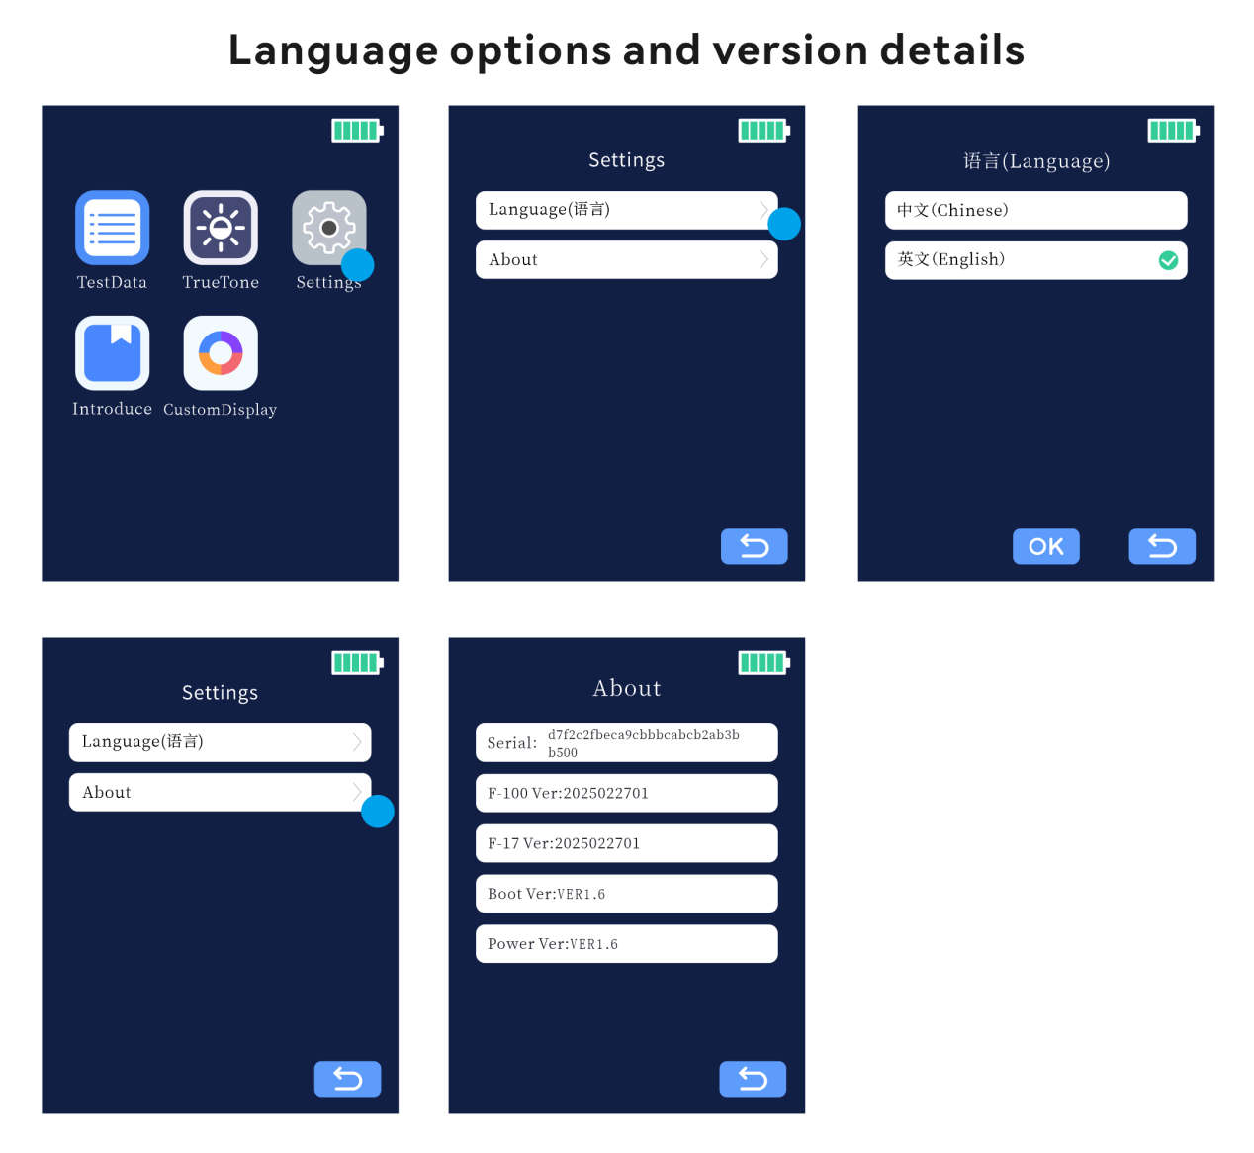
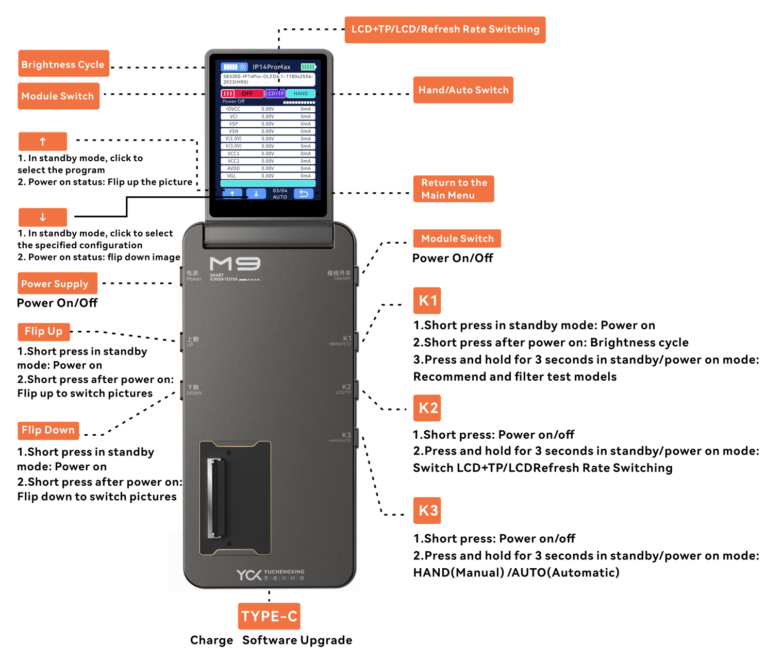

2.1Button Functions：
Power Button
Power On/Off: Turns the device on or off.
Module Switch
Power On/Off: Activates or deactivates the module.
K1 Button
Short press in standby: Powers on the device.
Short press when powered: Cycles through brightness levels.
Long press (3 seconds) in any state: Initiates model recommendation and filter testing.
K2 Button
Short press: Toggles Power On/Off.
Long press (3 seconds) in standby or powered state: Switches between LCD+TP, LCD-only, or refresh rate modes.
K3 Button
Short press: Toggles Power On/Off.
Long press (3 seconds) in standby or powered state: Switches between HAND (Manual) and AUTO (Automatic) modes.
Up Button
Short press in standby: Powers on the device.
Short press when powered: Cycles backward through display images.
Down Button
Short press in standby: Powers on the device.
Short press when powered: Cycles forward through display images.
Auto Shutdown
Powers off automatically after 10 minutes of inactivity in standby mode.
2.2 Schematic diagram of cable connection：
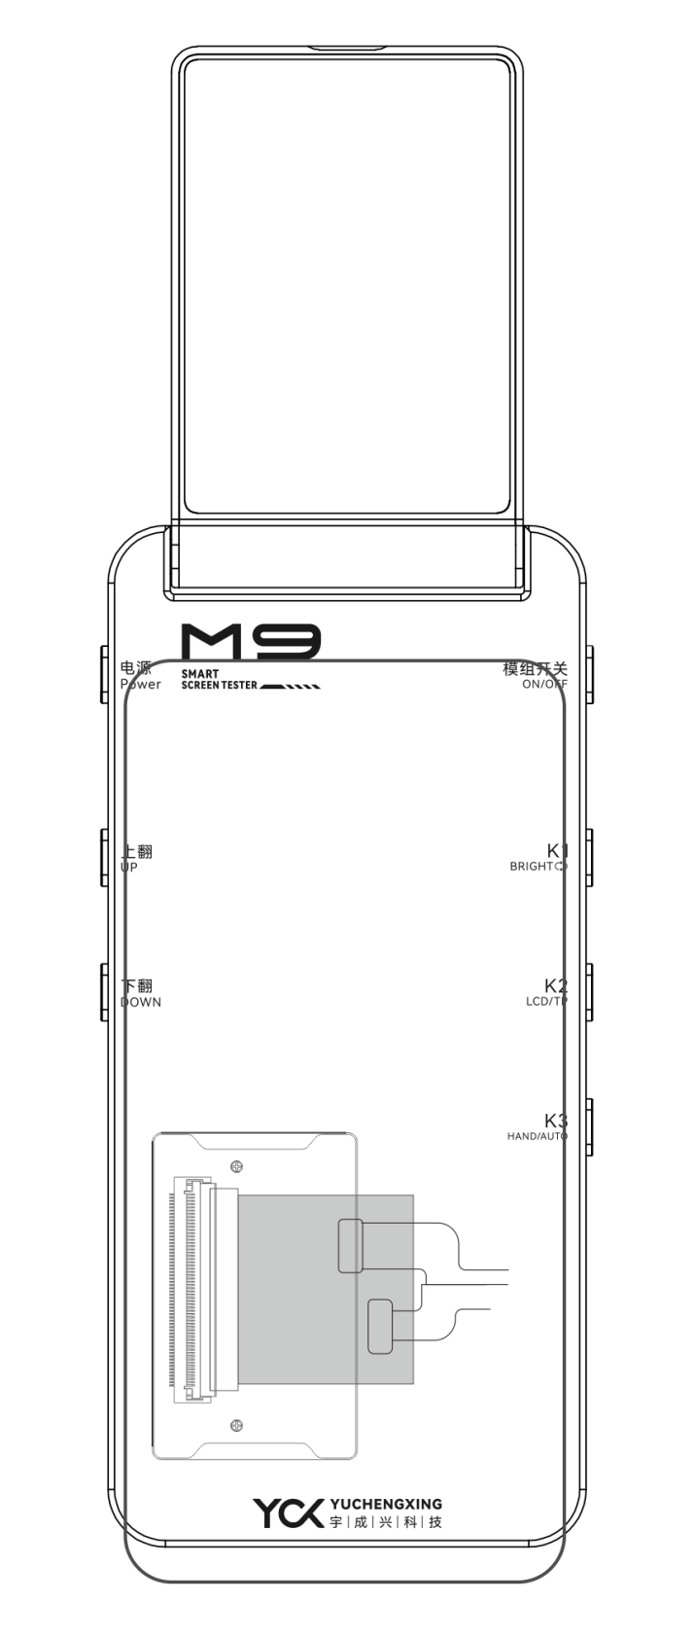

3 M9 Intelligent Screen Tester Power On/Off

Power On/Off Instructions：
Power On: Long press the Power button for 3 seconds to start the M9 Tester.
Power Off: Long press the Power button for 3 seconds to shut down the M9 Tester.

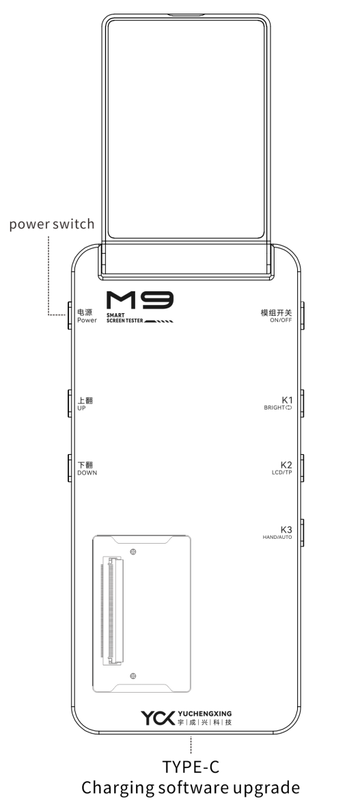

4 Screen Display Testing Procedure
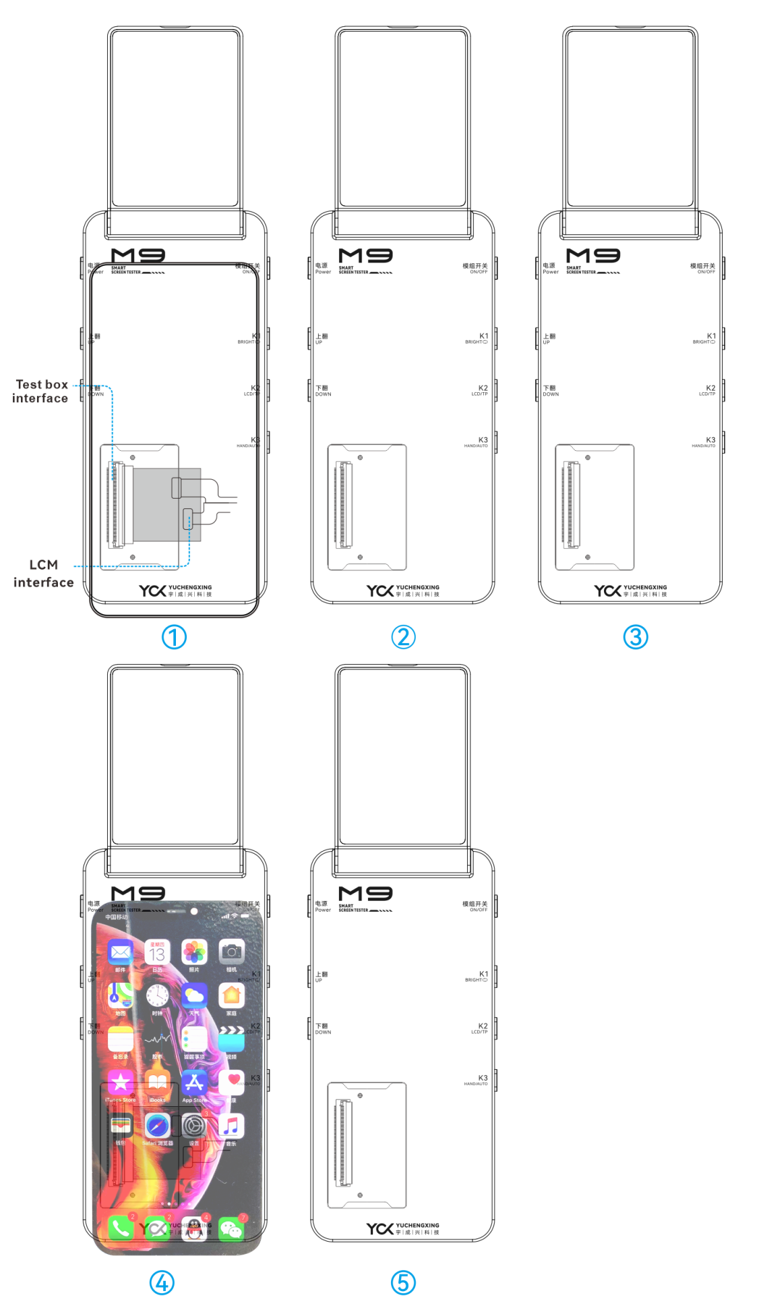
Step 1: Pre-Test Preparation
Connect the "screen under test" to the corresponding adapter board and flex cable.
Note: For eDP interface boards, use the flex cable labeled "eDP".

Step 2: Screen Activation & Testing
Mount the screen, then press any button except the Power button to activate the display.
Use the Up/Down buttons to cycle through test patterns and inspect visual performance.
Step 3: Screen Deactivation
Press the Module Switch/K2/K3 button to deactivate the screen.
Step 4: Repeat Testing Repeat Steps 1-3 to test additional screen units.
Note: Switching program: When the screen is not powered on, click the up button icon on the small screen to switch

5 Touch Line Drawing Test
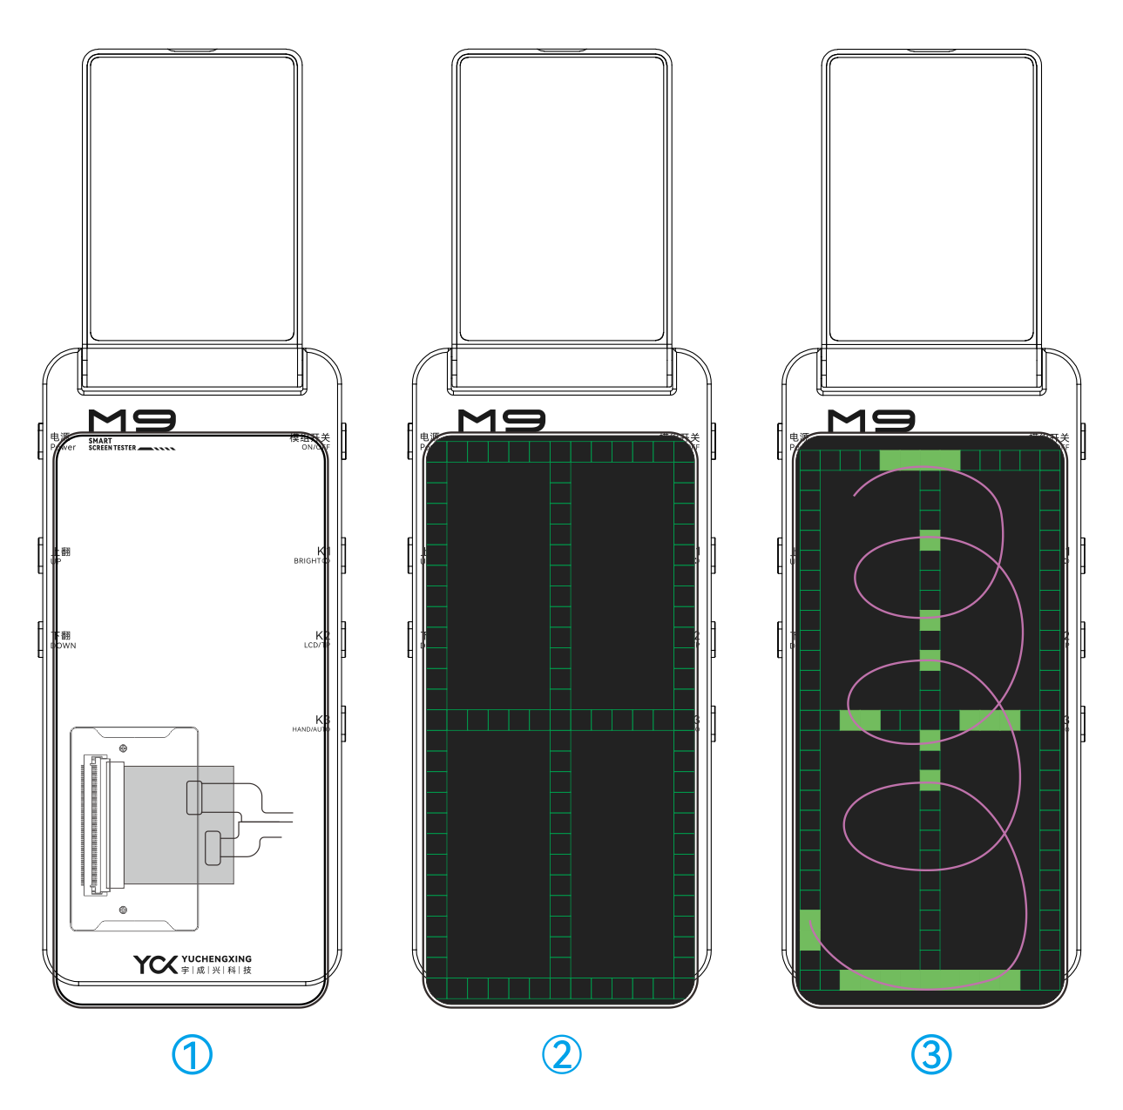
Step 1: Interface Navigation
After the screen under test is activated, press the Up/Down buttons to switch to the Touch Line Drawing Test interface.
Step 2: Functional Verification
Use your finger to draw continuous lines across the screen to validate touch accuracy and multi-point tracking performance.

6 Brightness Cycle Function
Step 1: Tap the Brightness Cycle icon in the top-right corner of the screen or press the K1 button to activate brightness cycling.
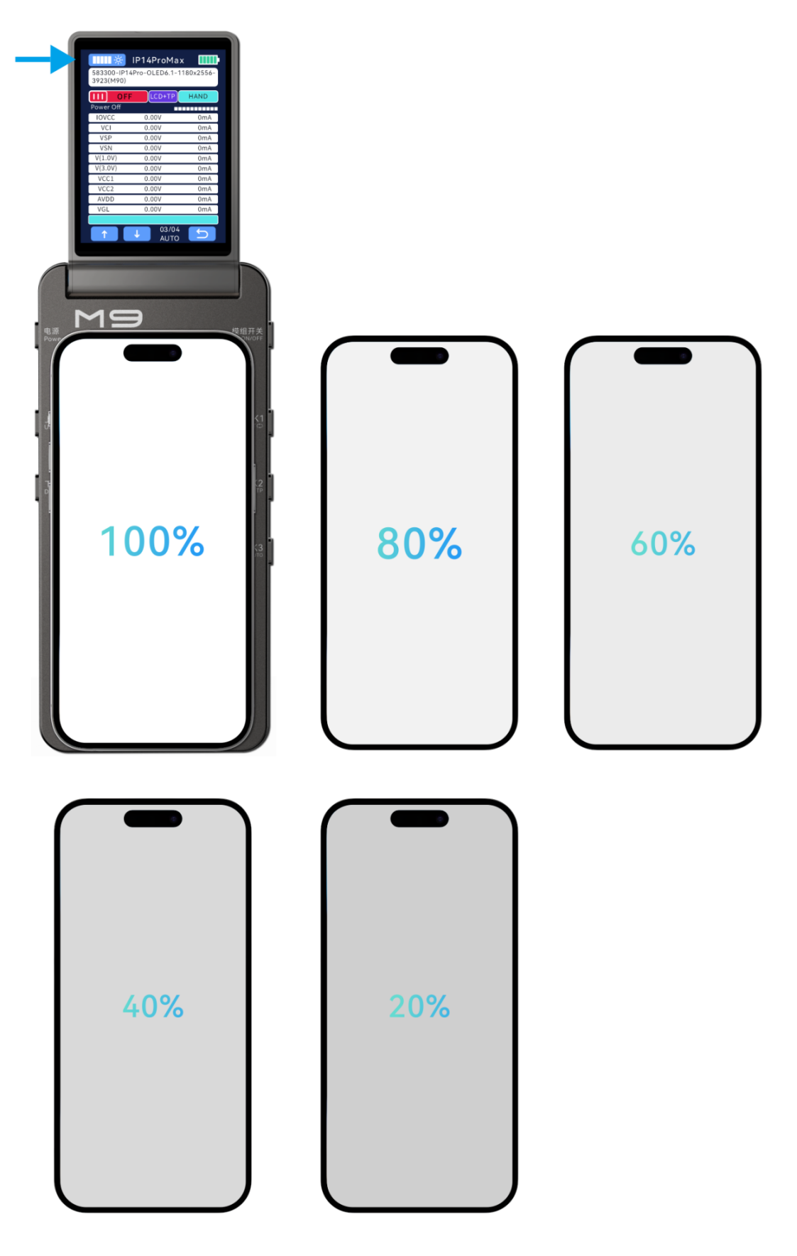
7 Screen True Color Restoration
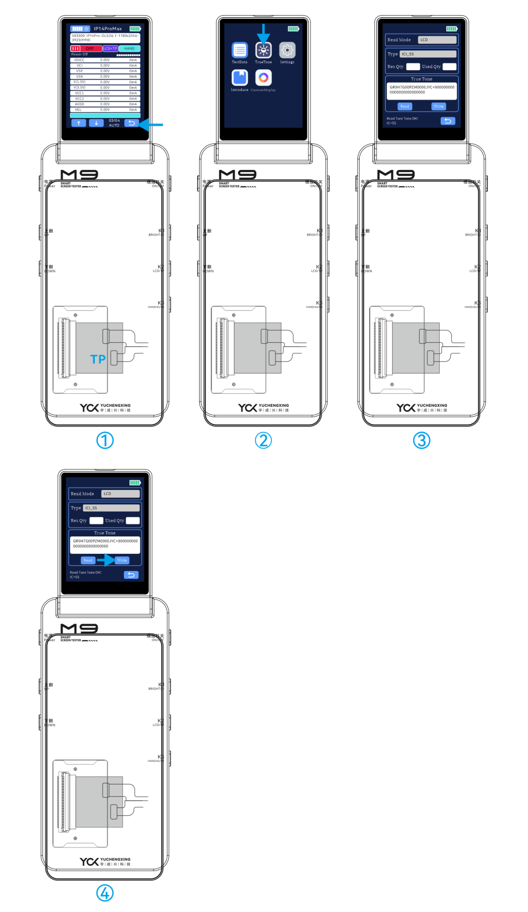
Step 1: Hardware Connection
Mount the screen to the corresponding adapter board and flex cable.
After the system recognizes the connected device, press the Back button to return to the Main Menu.

Step 2: Initiate True Color Restoration
Tap the True Color Restoration icon on the interface.

Step 3: Select Read Mode
Read Mode Options:
LCD: Direct read via display interface.
I2C: Read through I²C protocol.
PC: Requires connection to a host computer (software-controlled).
Switch Modes: Use the Up/Down buttons to toggle between modes.
Execute Read Operation:
Mount the source screen (the screen containing original color data).
Click the Read button.
Upon success, the message "Read Original Color OK!" will appear at the bottom of the screen.

Step 4: Write Original Color Data
Prepare Target Screen:
Remove the source screen and mount the target screen (the screen to be calibrated).
Click the Write button.
Completion Confirmation:
A success message "Write Original Color OK!" will display at the screen bottom.

8 APP Online Update Function
Yuchengxing Assistant APP Firmware Update: Package Acquisition

Download Firmware PackageChinese Users: Visit the official Chinese website: http://www.ycxbest.com/M960.htmlEnglish Users: Access the international portal: www.ycxbest.com/en/M960.html
Installation Guides: Download video tutorials and documentation from the same links.
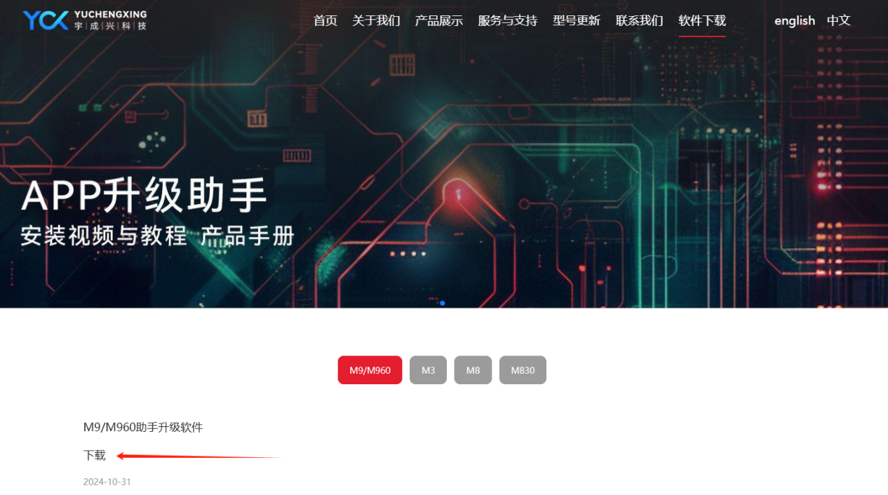
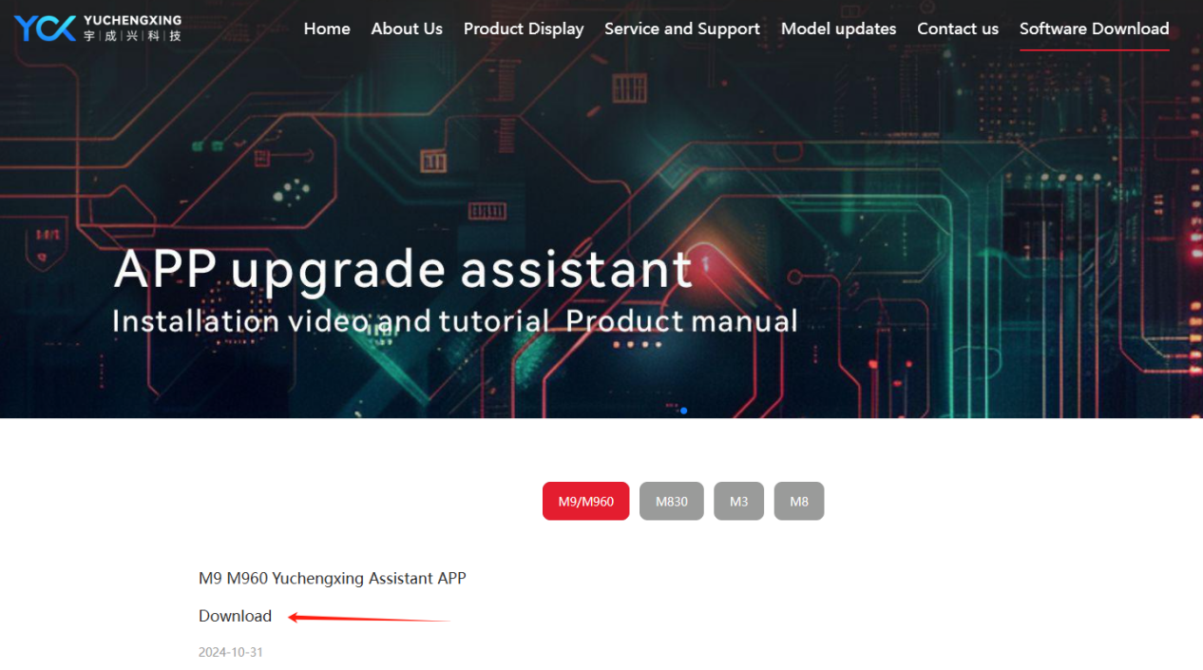

Update Procedure
After installation, log in to the APP.
Power on the device and connect it to a computer to initiate the firmware update.
Note: For detailed instructions, download the installation manual and video guides.

9 Product Specifications & Packaging
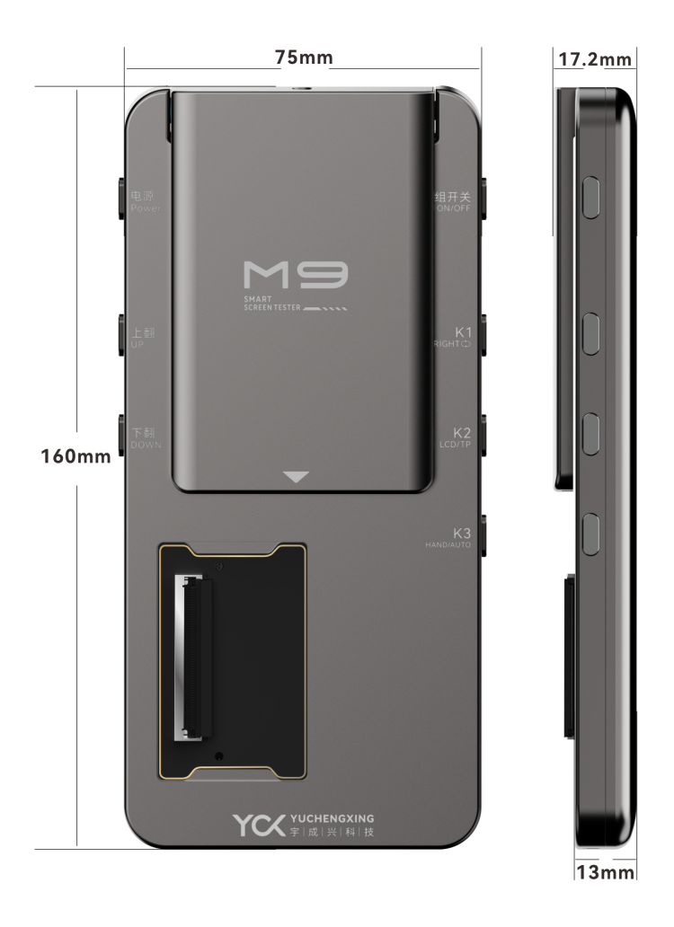
Product Parameters：
Model: M9
Battery model: Apple 11 (battery must be installed to use M9 normally)
Material: Aluminum Alloy
Color: Dark Gray
Power Supply: 5V/3A，Support iphone fast charging protocol 9V/2A
Power Interface: Type-C
Operating Temperature: 25℃ to 85℃
Operating Humidity: <90% RH
Dimensions: 160mm × 75mm × 13mm
Storage Conditions: -30℃ to 85℃, <90% RH

Package Contents：M9 Screen Tester、 Type-C Charging Cable
Packaging Details
Box Dimensions: 178.2mm × 95.76mm × 40.75mm
Total Weight: 375g (including packaging box, M9 tester, and cable) ±10g
M9 Bare Unit Weight: 246.2g ±10g

10 Warranty & Non-Warranty Terms
Warranty Coverage：
- 7-Day Policy
Within 7 days from the date of receipt, if the product exhibits performance failures confirmed by our after-sales service center, you are entitled to free return, replacement, or repair.
2.8-15 Day Policy
Between 8-15 days from the date of receipt, confirmed performance failures qualify for free replacement or repair.
3.1-Year Limited Warranty
Within 1 year from the date of receipt, confirmed performance failures qualify for free repair services.
- Non-Warranty Cases: 4.1. Damage caused by unauthorized disassembly, repair, misuse, modification, or improper storage. 4.2.Use of non-original accessories or tampering with product labels (e.g., tearing, altering).
4.3.Products exceeding the warranty period.
4.4.Damage due to natural disasters or force majeure.
4.5. Damage caused by using non-compliant chargers (exceeding specified voltage ratings).
5.*Final Interpretation Rights
Yuchengxing Electronics Technology Co., Ltd. reserves the right to interpret these terms within legal limits.

11 Usage Precautions
Power Supply
Ensure the power supply voltage matches the device's rated voltage before connecting to the testing box.
Use original manufacturer-provided charging cables.
Additional Guidelines：
1.Environmental Conditions
Avoid using the device in high-temperature or humid environments to prevent reduced lifespan or damage.
2.Interface Compliance
Input/output ports are clearly labeled. Ensure correct connections during operation.
3.Tampering Prohibition
Do not disassemble the device, as this may cause damage or compromise testing accuracy.
4.Maintenance
Regularly clean accumulated dust and debris to maintain device hygiene.
5.Mechanical Stress
Protect the device from mechanical shocks or impacts.

