**M9 Screen Tester**

**Product Manual**

**V1.0**

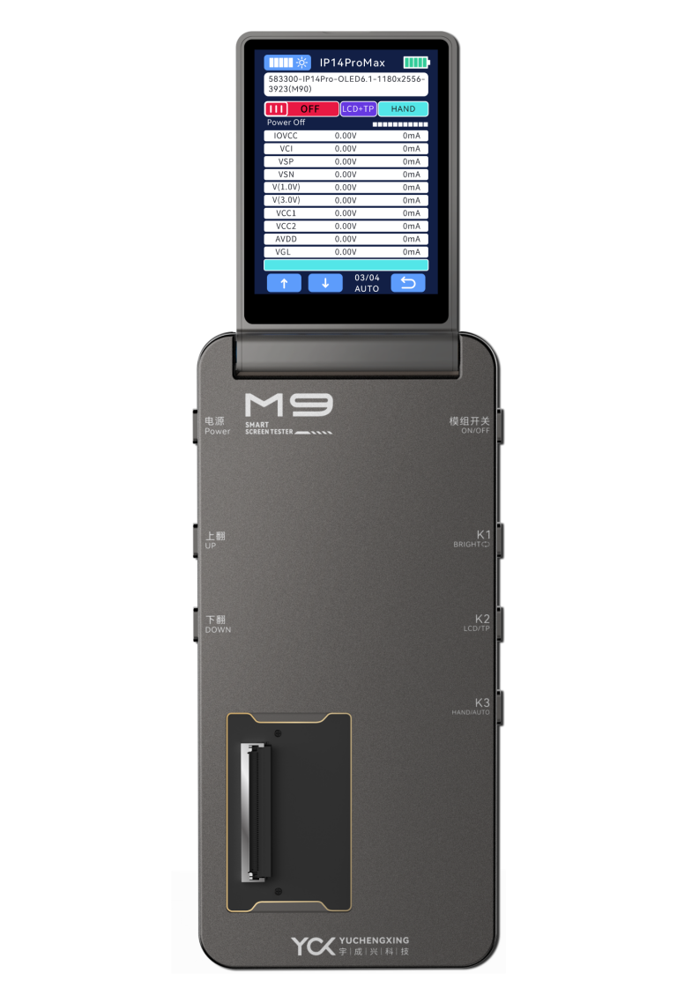

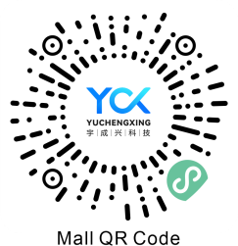 

Shenzhen Yuchengxing Electronics Technology Co., Ltd.

Address: 3F, Building 4, Rihai Intelligent Technology Park, Longhua District, Shenzhen, China

Service Hotline: +86-755-23221950

Note: Images are for illustrative purposes only. Actual product appearance may vary.

## Table of Contents

### 1.1Product Advantages....................................................4

### 1.2Main Function Menu Description...............................5

### 2.1Button Functions.........................................................7

### 2.2Flex Cable Connection Diagram.................................8

### 3.M9 Tester Power On/Off................................................9

### 4.Screen Display Testing..................................................11

### 5.Touch Line Drawing Test..............................................13

### 6.Brightness Cycle............................................................14

### 7.True Color Restoration..................................................15

### 8.APP Upgrade..................................................................16

### 9.Product Specifications & Packaging........................... 18

### 10.Warranty & Non-Warranty Terms...............................19

### 11.Usage Precautions......................................................20

**1.1 Product Advantages：**

1.Multi-Interface Compatibility

Supports eDP (ALP-DP), MIPI, and QSPI interfaces, enabling full-speed eDP signal display output.

1. Universal Screen Compatibility

Compatible with displayand touch testing for OLED, TFT, Original (OEM), Aftermarket, and Compressed screens.

1. Modular Battery Design

Features replaceable batteries (Model: IP11) for extended operational uptime.

1. Real-Time Power Monitoring

Built-in voltage/current acquisition module for real-time screen power consumption tracking.

1. Multi-Layer Circuit Protection

Integrated multi-stage over-current (OCP) and over-voltage (OVP) protection within the test box.

1. Custom Display Configuration

Supports user-defined screen content (static images/dynamic videos).

1. Apple True Tone Restoration

Enables True Tone display calibration and color temperature recovery for Apple devices.

1. Firmware Upgradable via App

Supports wireless OTA (Over-The-Air) updates for test protocols and software versions.

9.Brightness Cycle Testing

Executes 0-1000nit brightness step cycling to validate backlight stability.

10.Refresh Rate Verification

Tests dynamic refresh rates (e.g., 60Hz/90Hz/120Hz) and detects frame rate jitter.

11.LCD Driver IC Identification

Automatically reads LCD driver IC models (e.g., ILI9881, ST7789).

12.Comprehensive & Rapid Updates

Covers mainstream screen models with database updates delivered within ≤48 hours.

1.2Product Main Function Menu Description：

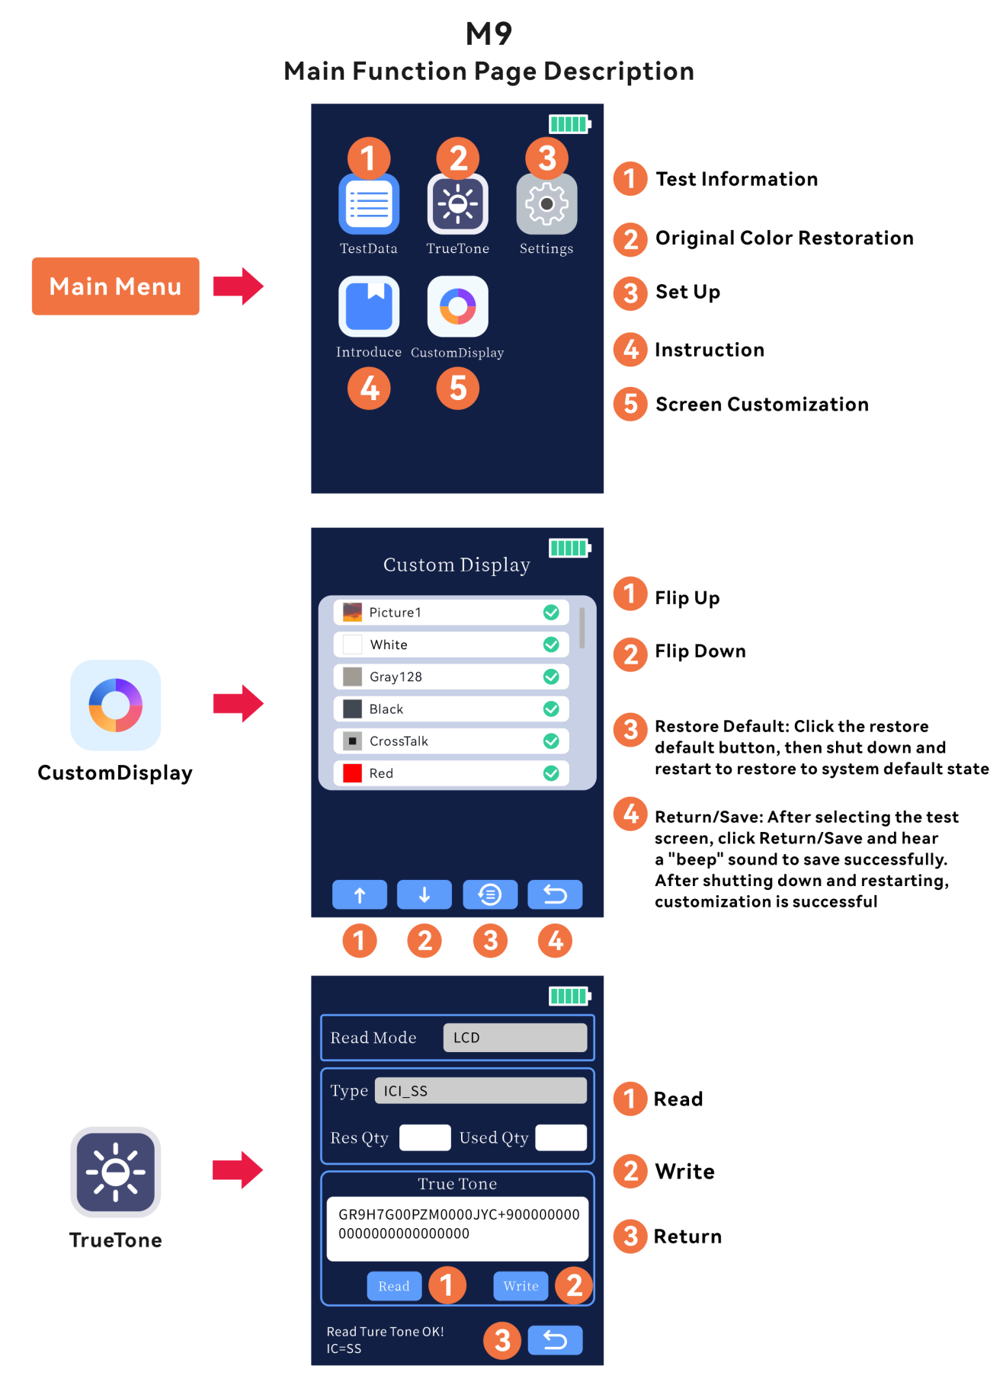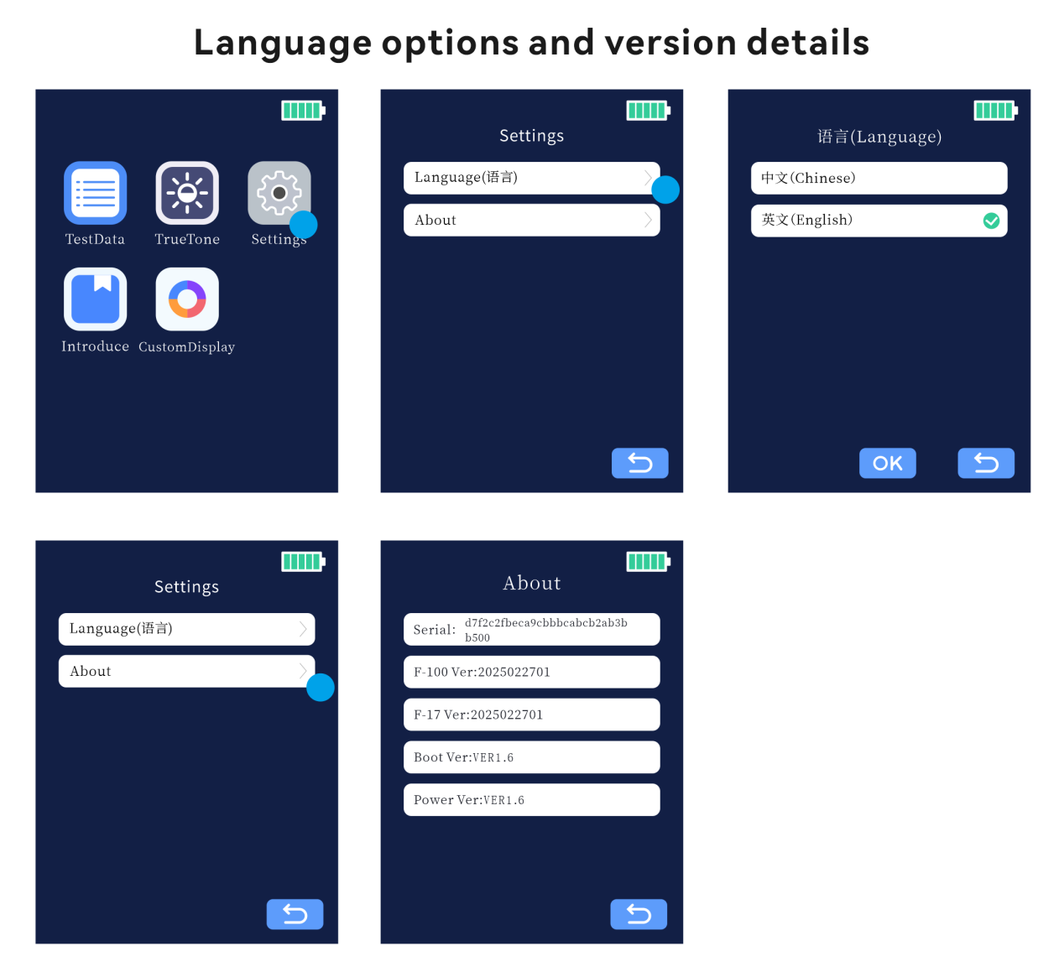

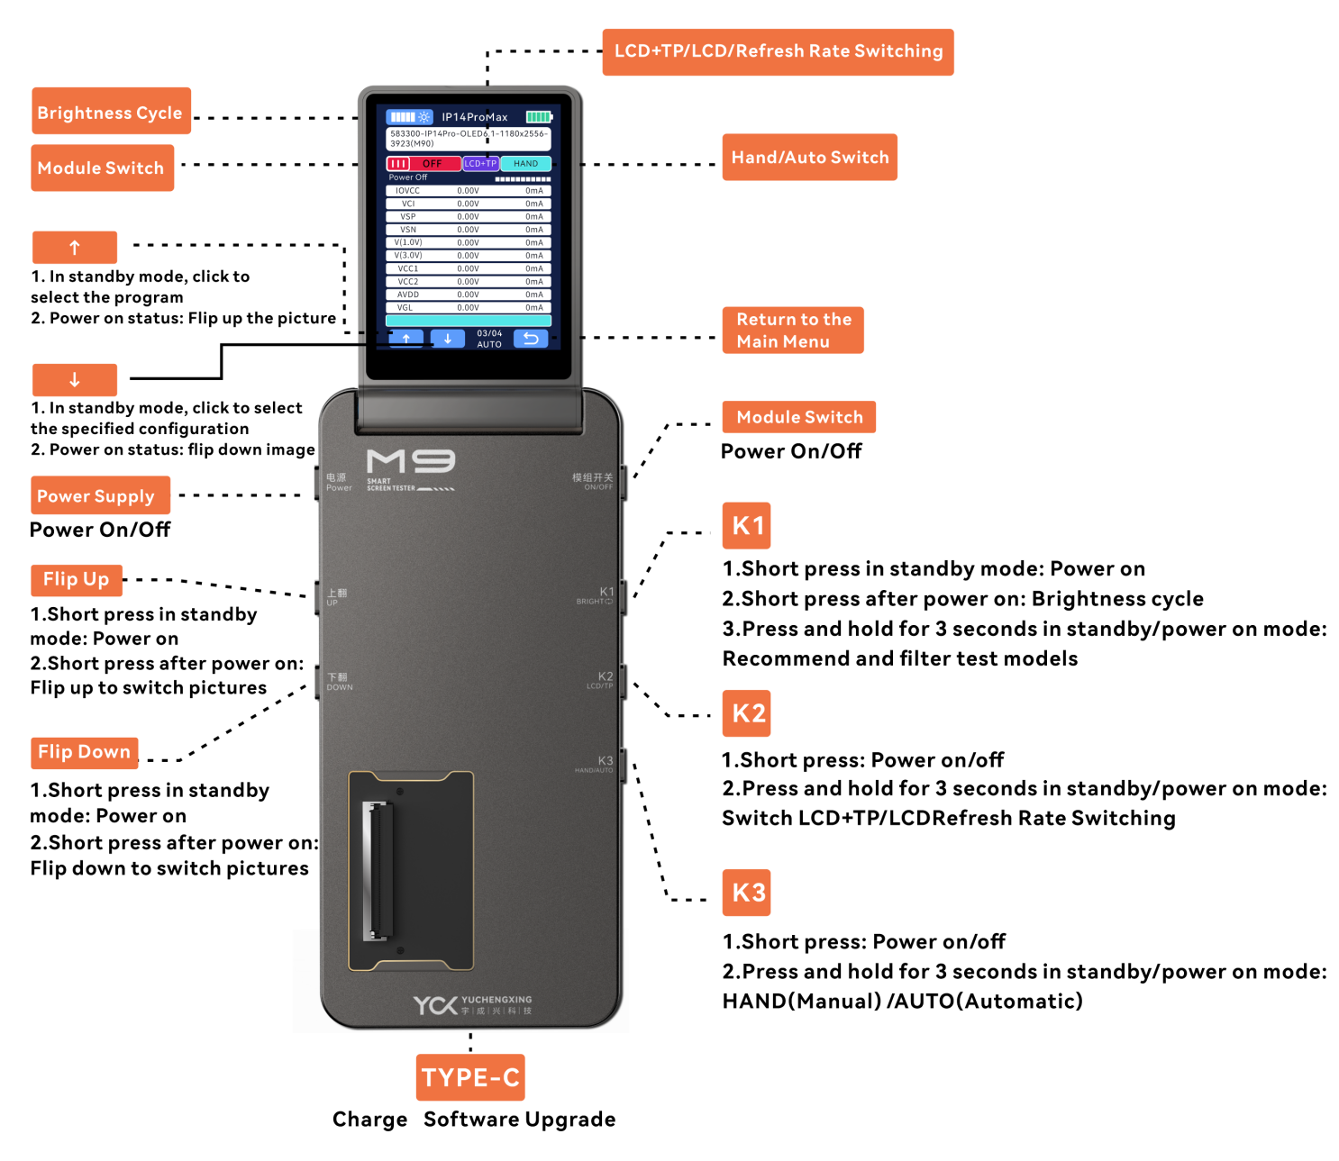

2.1Button Functions：

Power Button

Power On/Off: Turns the device on or off.

Module Switch

Power On/Off: Activates or deactivates the module.

K1 Button

Short press in standby: Powers on the device.

Short press when powered: Cycles through brightness levels.

Long press (3 seconds) in any state: Initiates model recommendation and filter testing.

K2 Button

Short press: Toggles Power On/Off.

Long press (3 seconds) in standby or powered state: Switches between LCD+TP, LCD-only, or refresh rate modes.

K3 Button

Short press: Toggles Power On/Off.

Long press (3 seconds) in standby or powered state: Switches between HAND (Manual) and AUTO (Automatic) modes.

Up Button

Short press in standby: Powers on the device.

Short press when powered: Cycles backward through display images.

Down Button

Short press in standby: Powers on the device.

Short press when powered: Cycles forward through display images.

Auto Shutdown

Powers off automatically after 10 minutes of inactivity in standby mode.

2.2 Schematic diagram of cable connection：

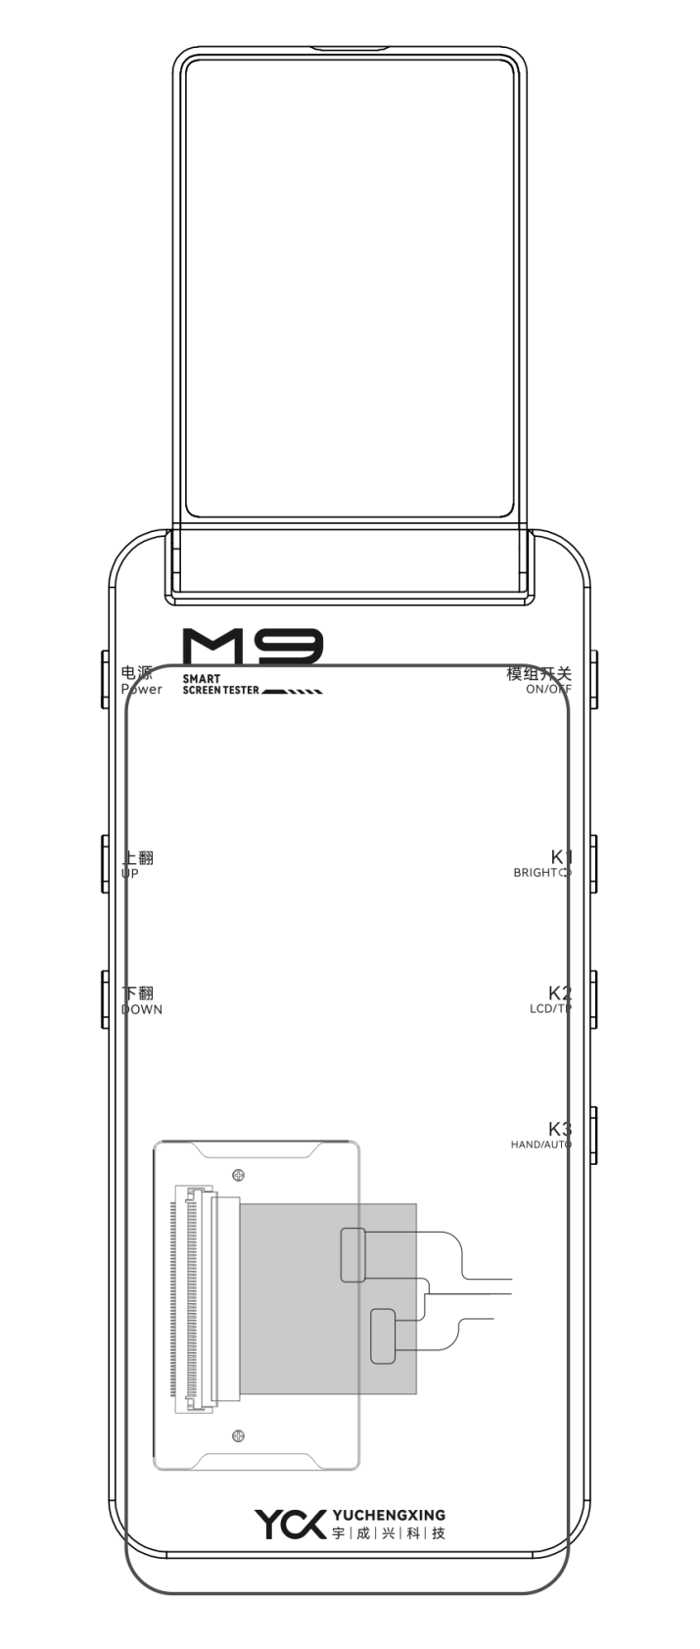

3 M9 Intelligent Screen Tester Power On/Off

Power On/Off Instructions：

Power On: Long press the Power button for 3 seconds to start the M9 Tester.

Power Off: Long press the Power button for 3 seconds to shut down the M9 Tester.

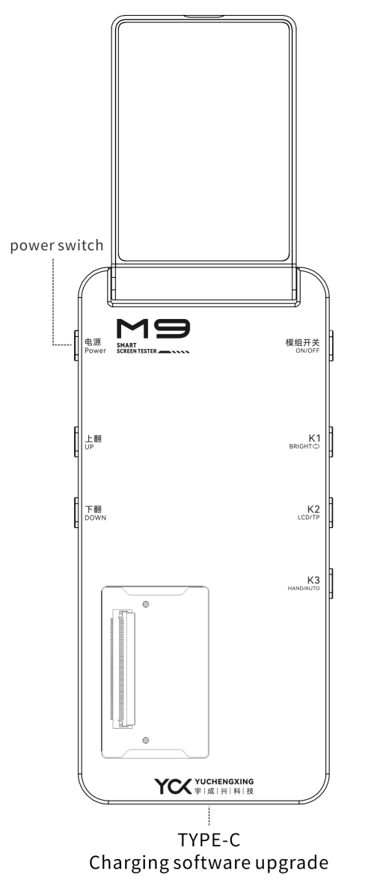

4 Screen Display Testing Procedure

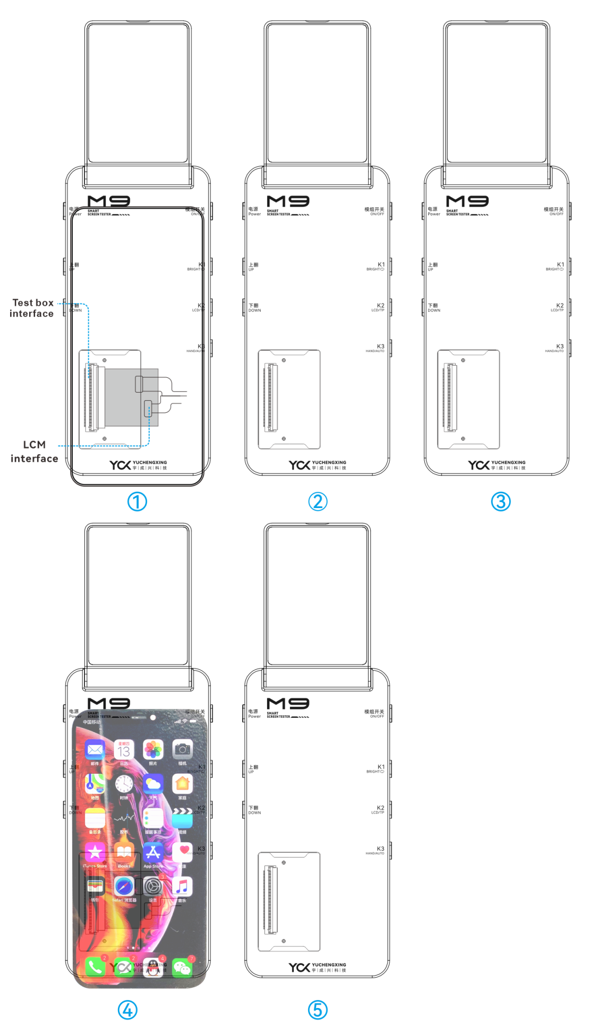

Step 1: Pre-Test Preparation

Connect the "screen under test" to the corresponding adapter board and flex cable.

Note: For eDP interface boards, use the flex cable labeled "eDP".

Step 2: Screen Activation & Testing

Mount the screen, then press any button except the Power button to activate the display.

Use the Up/Down buttons to cycle through test patterns and inspect visual performance.

Step 3: Screen Deactivation

Press the Module Switch/K2/K3 button to deactivate the screen.

Step 4: Repeat Testing

Repeat Steps 1-3 to test additional screen units.

Remarks Program Switching:

In the powered-off state, press the Up/Down arrow icons on the sub-display to switch test programs (requires firmware configuration via technical support).

5  Touch Line Drawing Test

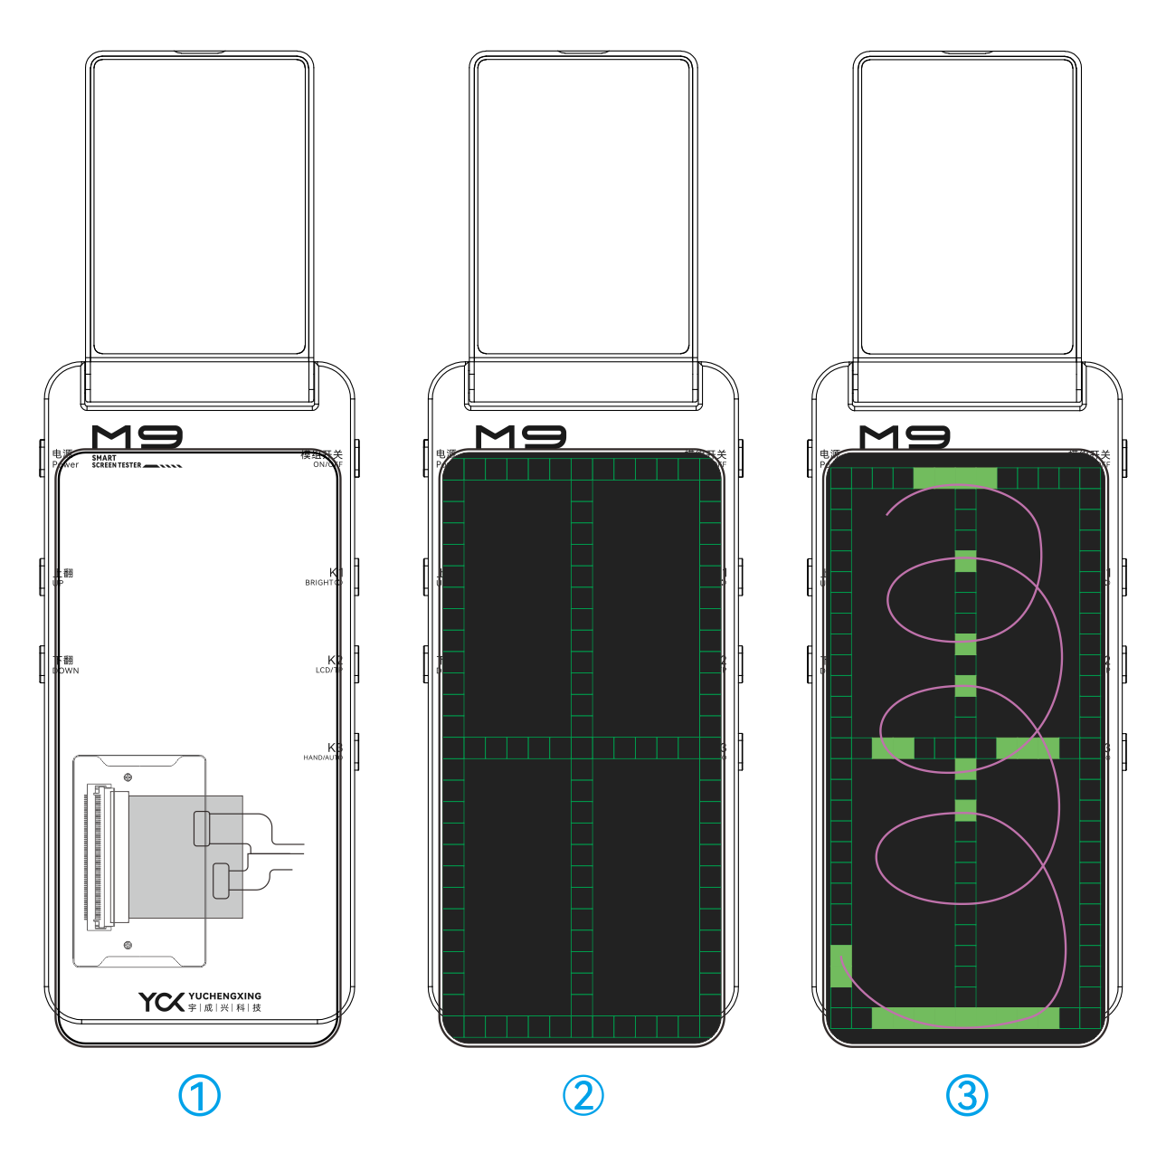

Step 1: Interface Navigation

After the screen under test is activated, press the Up/Down buttons to switch to the Touch Line Drawing Test interface.

Step 2: Functional Verification

Use your finger to draw continuous lines across the screen to validate touch accuracy and multi-point tracking performance.

6 Brightness Cycle Function

Step 1: Tap the Brightness Cycle icon in the top-right corner of the screen or press the K1 button to activate brightness cycling.

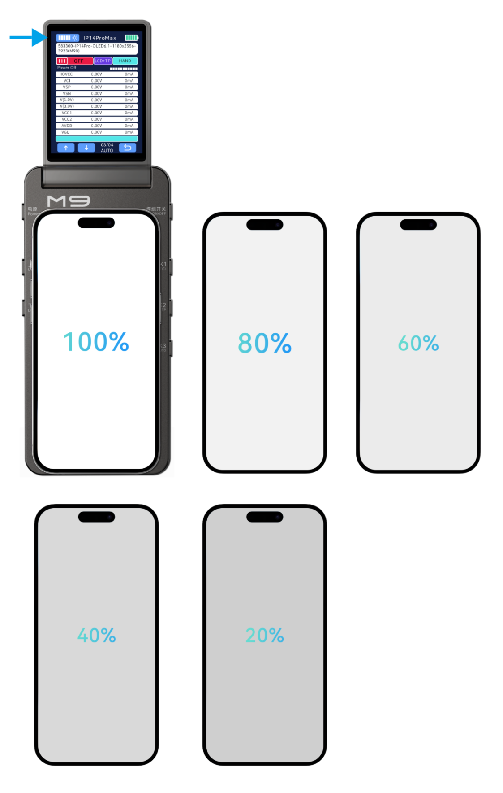

7 Screen True Color Restoration

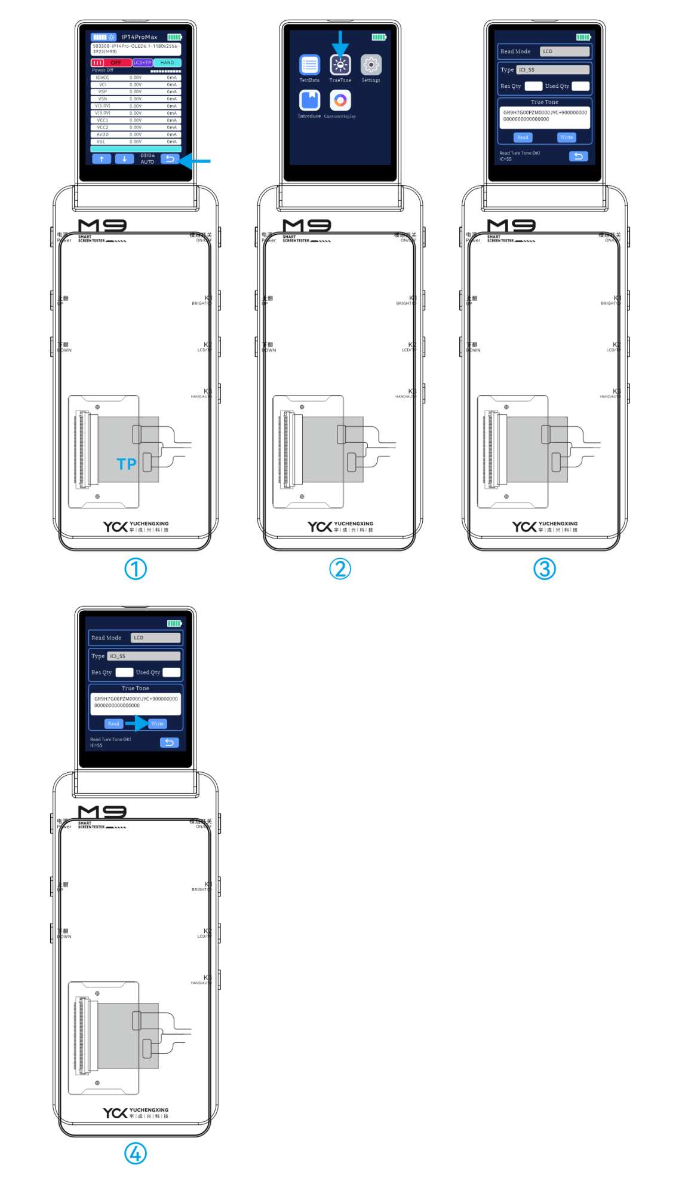

Step 1: Hardware Connection

Mount the screen to the corresponding adapter board and flex cable.

After the system recognizes the connected device, press the Back button to return to the Main Menu.

Step 2: Initiate True Color Restoration

Tap the True Color Restoration icon on the interface.

Step 3: Select Read Mode

Read Mode Options:

LCD: Direct read via display interface.

I2C: Read through I²C protocol.

PC: Requires connection to a host computer (software-controlled).

Switch Modes: Use the Up/Down buttons to toggle between modes.

Execute Read Operation:

Mount the source screen (the screen containing original color data).

Click the Read button.

Upon success, the message "Read Original Color OK!" will appear at the bottom of the screen.

Step 4: Write Original Color Data

Prepare Target Screen:

Remove the source screen and mount the target screen (the screen to be calibrated).

Click the Write button.

Completion Confirmation:

A success message "Write Original Color OK!" will display at the screen bottom.

8 APP Online Update Function

Yuchengxing Assistant APP Firmware Update: Package Acquisition

Download Firmware PackageChinese Users: Visit the official Chinese website: http://www.ycxbest.com/M960.htmlEnglish Users: Access the international portal: www.ycxbest.com/en/M960.html

Installation Guides: Download video tutorials and documentation from the same links.

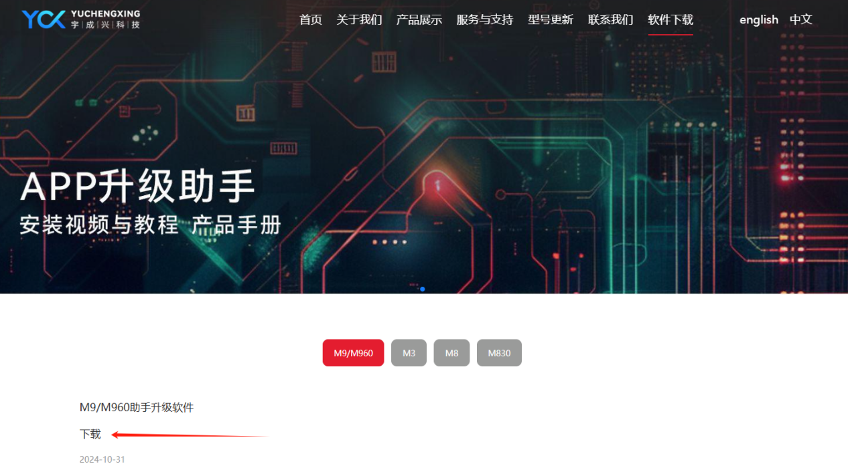

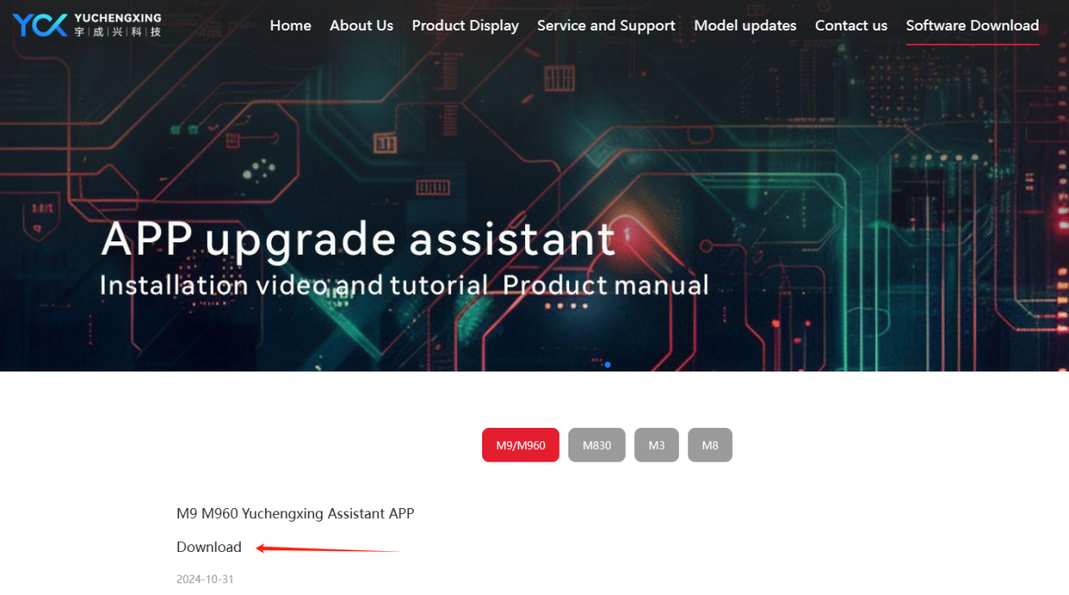

Update Procedure

After installation, log in to the APP.

Power on the device and connect it to a computer to initiate the firmware update.

Note: For detailed instructions, download the installation manual and video guides.

9 Product Specifications & Packaging

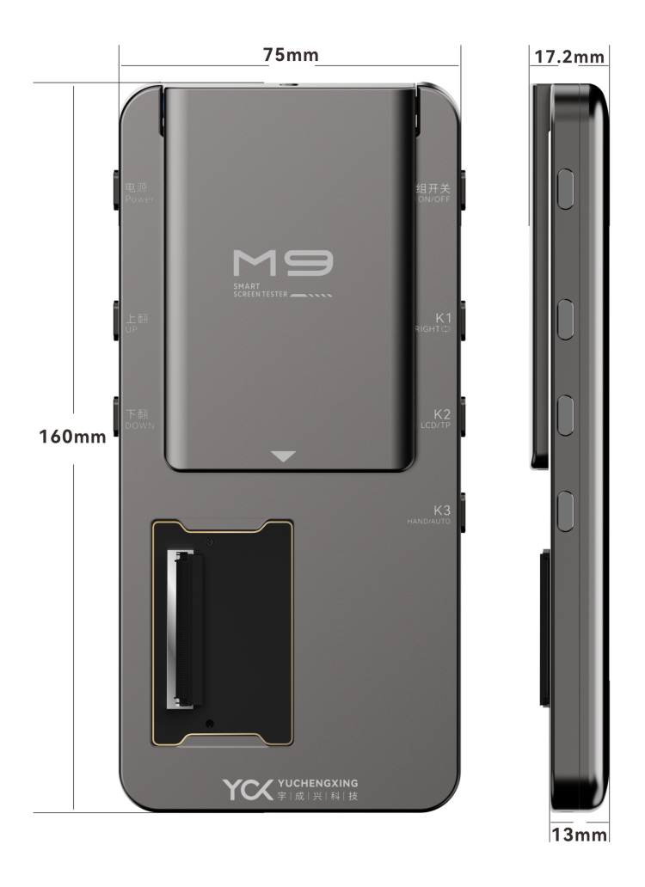

Product Parameters：

Model: M9

Battery model: Apple 11 (battery must be installed to use M9 normally)

Material: Aluminum Alloy

Color: Dark Gray

Power Supply: 5V/2A or 9V/2A

Power Interface: Type-C

Operating Temperature: 25℃ to 85℃

Operating Humidity: <90% RH

Dimensions: 160mm × 75mm × 13mm

Storage Conditions: -30℃ to 85℃, <90% RH

Package Contents：M9 Screen Tester、 Type-C Charging Cable

Packaging Details

Box Dimensions: 178.2mm × 95.76mm × 40.75mm

Total Weight: 375g (including packaging box, M9 tester, and cable) ±10g

M9 Bare Unit Weight: 246.2g ±10g

10 Warranty & Non-Warranty Terms

Warranty Coverage：

1. 7-Day Policy

Within 7 days from the date of receipt, if the product exhibits performance failures confirmed by our after-sales service center, you are entitled to free return, replacement, or repair.

2.8-15 Day Policy

Between 8-15 days from the date of receipt, confirmed performance failures qualify for free replacement or repair.

3.1-Year Limited Warranty

Within 1 year from the date of receipt, confirmed performance failures qualify for free repair services.

1. Non-Warranty Cases: 4.1. Damage caused by unauthorized disassembly, repair, misuse, modification, or improper storage. 4.2.Use of non-original accessories or tampering with product labels (e.g., tearing, altering).

4.3.Products exceeding the warranty period.

4.4.Damage due to natural disasters or force majeure.

4.5. Damage caused by using non-compliant chargers (exceeding specified voltage ratings).

5.*Final Interpretation Rights

Yuchengxing Electronics Technology Co., Ltd. reserves the right to interpret these terms within legal limits.

11 Usage Precautions

Power Supply

Ensure the power supply voltage matches the device's rated voltage before connecting to the testing box.

Use original manufacturer-provided charging cables.

Additional Guidelines：

1.Environmental Conditions

Avoid using the device in high-temperature or humid environments to prevent reduced lifespan or damage.

2.Interface Compliance

Input/output ports are clearly labeled. Ensure correct connections during operation.

3.Tampering Prohibition

Do not disassemble the device, as this may cause damage or compromise testing accuracy.

4.Maintenance

Regularly clean accumulated dust and debris to maintain device hygiene.

5.Mechanical Stress

Protect the device from mechanical shocks or impacts.