YCX M3 Upgrade Assistant Installation Instruction

1.Extract the M3 Upgrade Assistant Installation File

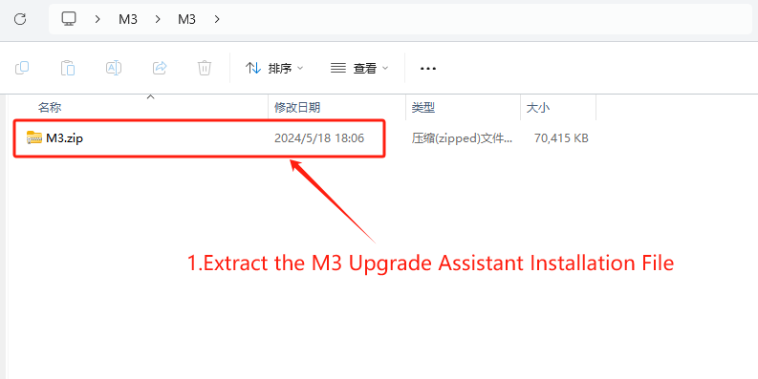

2.Open the Decompressed M3 Folder and open the Operating Environment Folder

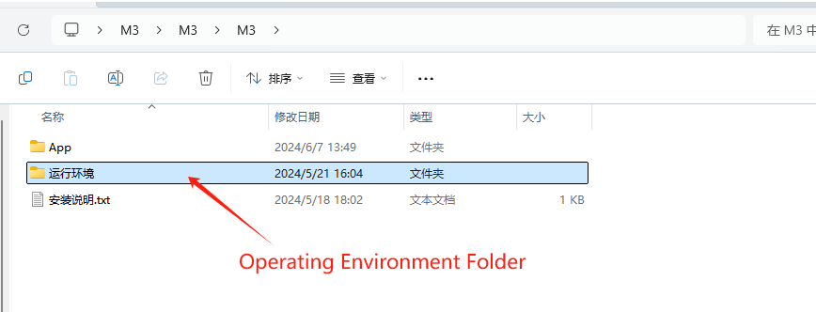

3.Double-click to install”windowsdesktop-runtime-8.0.2-win-x64.exe”in the Operating Environment Folder (Skip this step if you have already installed)

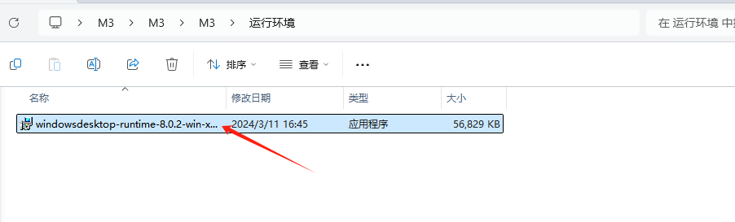

3-1

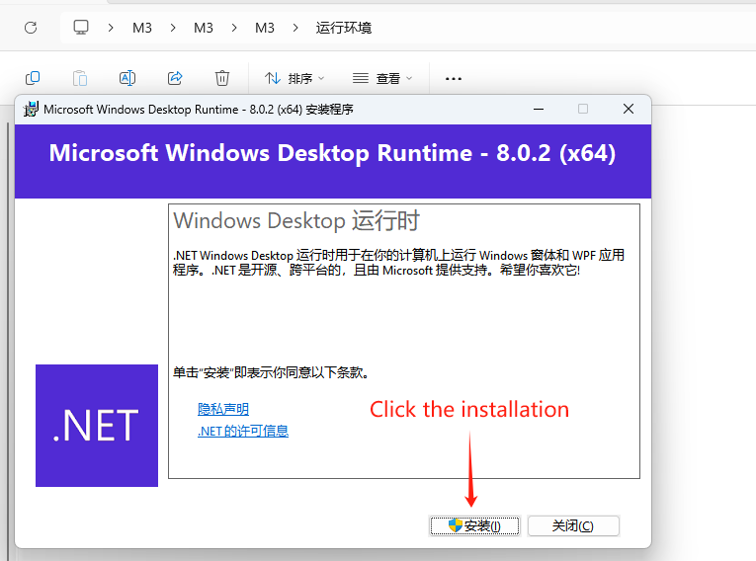

3-2

Click the Close after installation

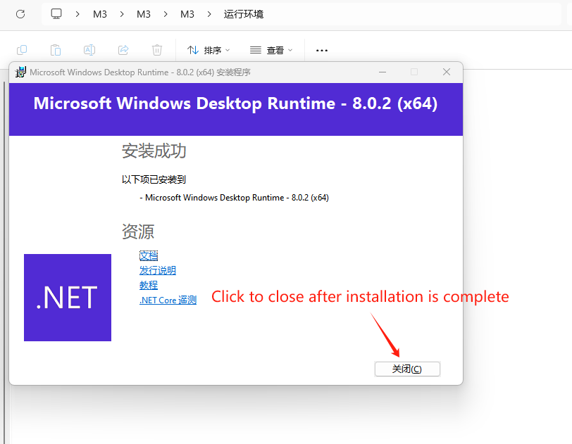

3-3.Double-click to install and this page will appear. This is the status of the installed running environment

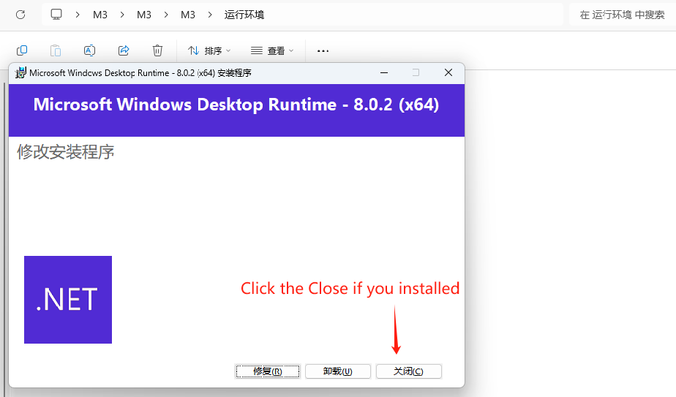

4：Right click on the administrator to run 'Run Environment \ vc2015-2022.bat' (if installed, please skip)

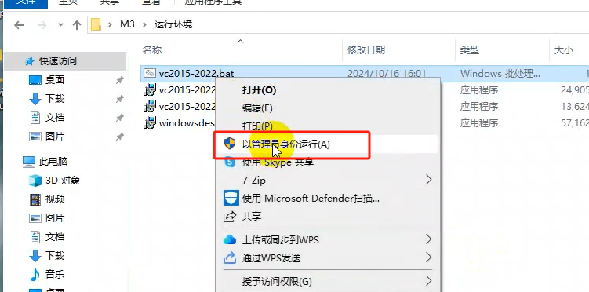

4-1：setup script

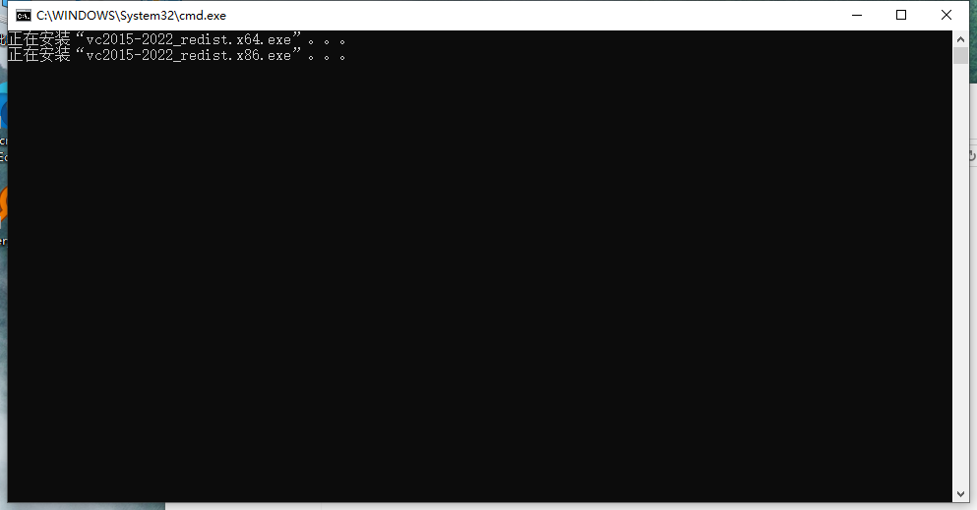

5：Double click to install 'Driver \ RiverAssitant-v5.1.1 \ RiverInstall. exe' (if already installed, please skip)

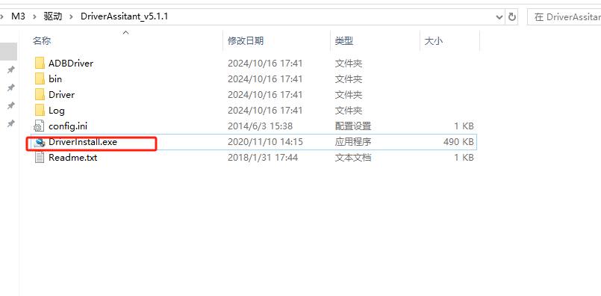

5-1 Click on 'Driver Installation'

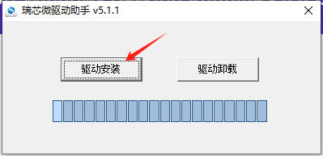

5-2 installation is complete

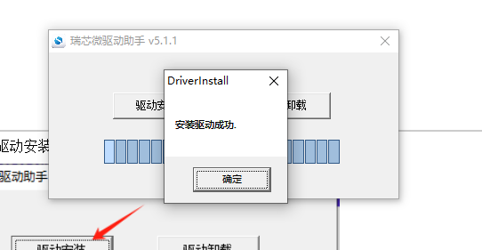

6.Return to the previous folder and open the APP folder,double-click to run the "YCX.M3App.exe" application program

6-1

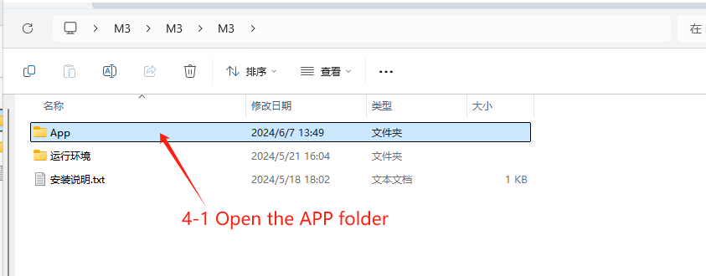

6-2. Double-click to open the M3 Upgrade Assistant(Suggest creating desktop shortcut)

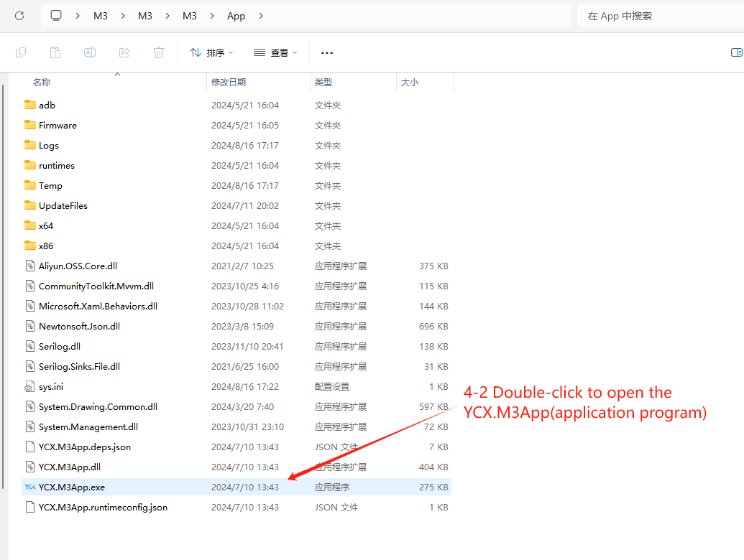

7.Connect M3 with a Type-C data cable, after successful connection, click the one click upgrade

7-1 Connect M3 with a Type-C data cable

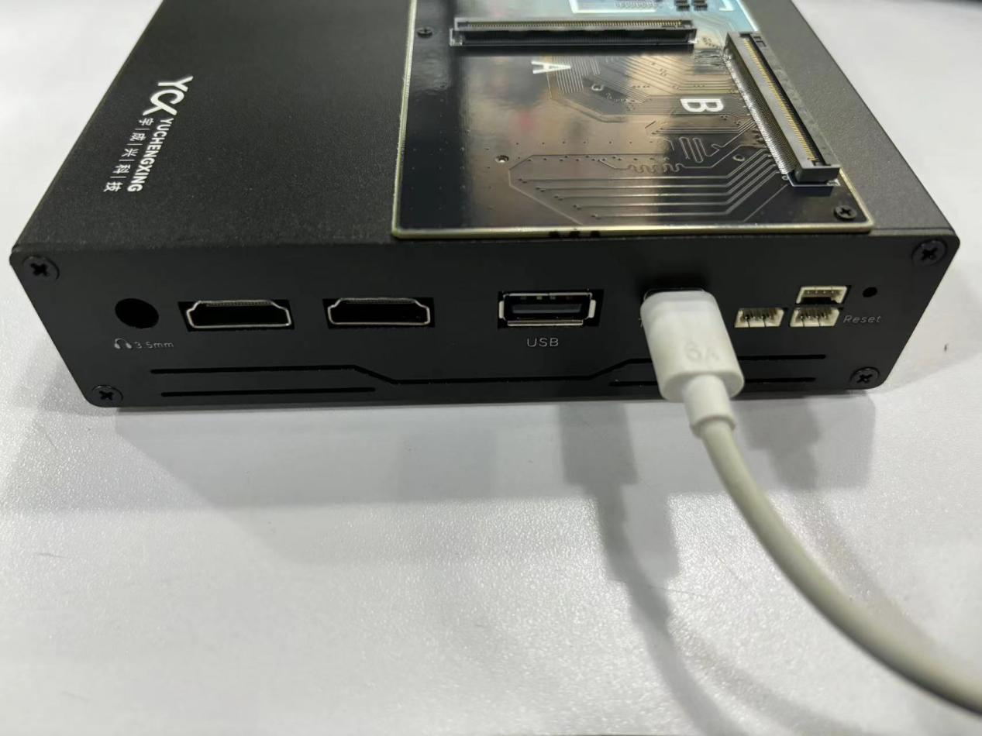

7-2 After successful connection, click the one click upgrade

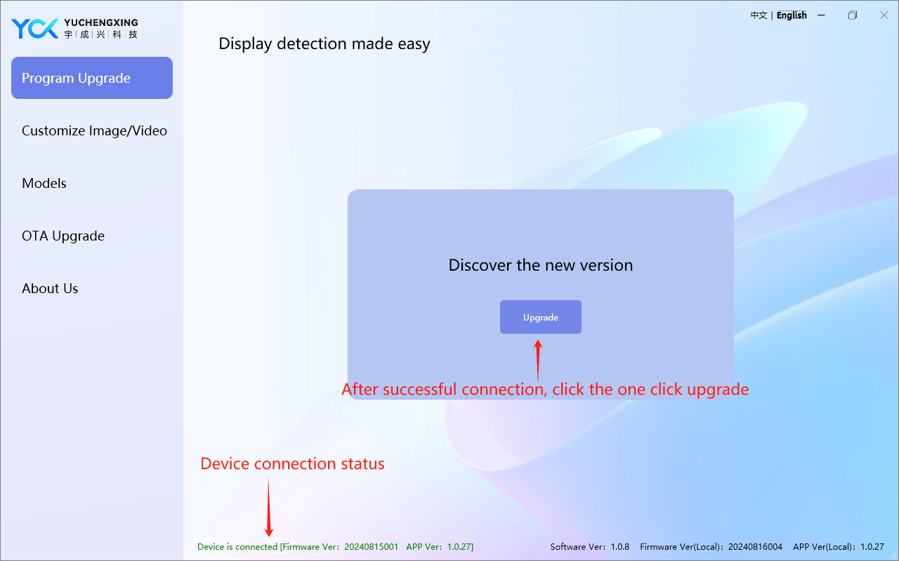

7-3 Upgrade successful

