**Module Analyzer**

**M3 Product manual**

**V1.0**

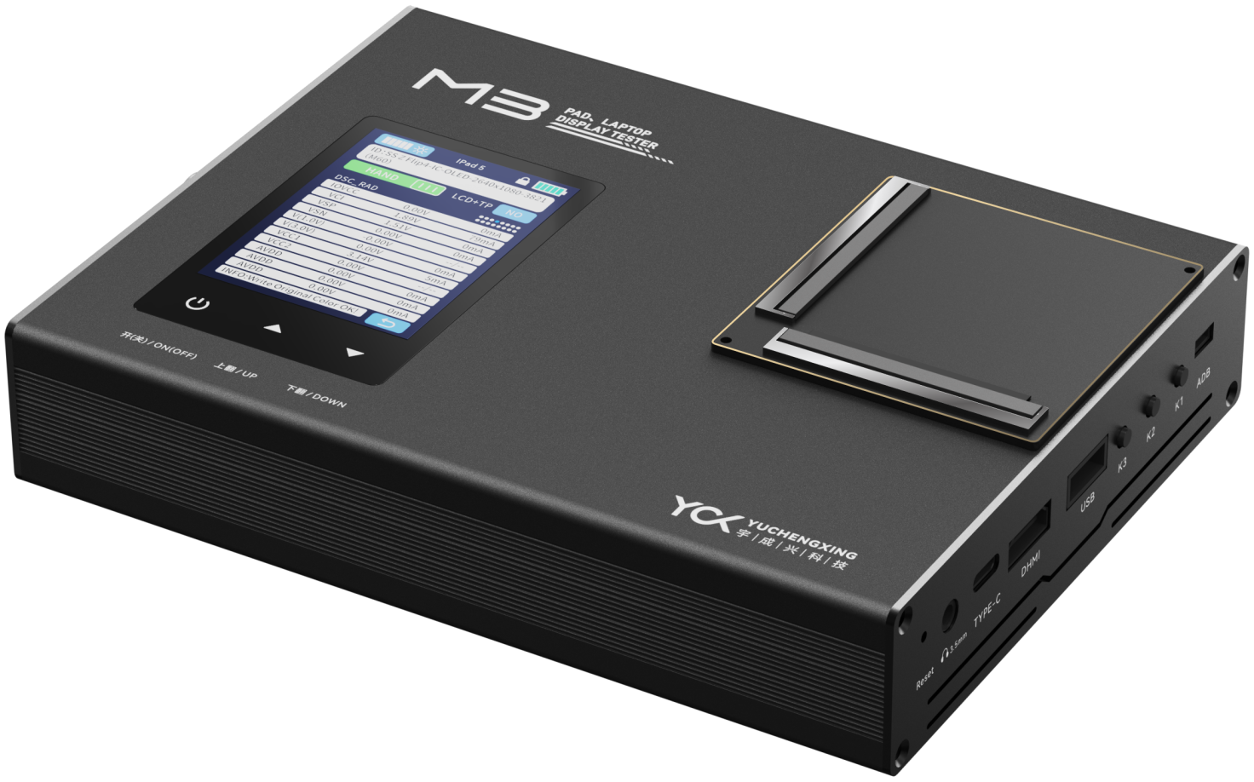

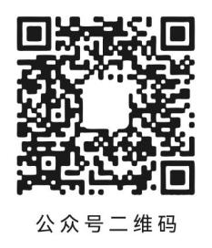

**WeChat Mall QR Code**

**WeChat public**

**account QR code**

Shenzhen Yuchengxing Technology Co., Ltd.

Floor 4, Building 10, Jinxiu Science Park, Longhua District, Shenzhen

Service Hotline：0755-23221950

The pictures are for reference only. The actual appearance shall prevail.

**Security Summary**

When servicing this instrument, attention must be paid to the following general safety precautions. Failure to comply with these precautions and any explicit warnings in this instruction manual will violate the safety standards for the design, manufacture, and use of the instrument.

**Preparation before powering on**

Check that the power supply meets the rated input value of the instrument.

**Protective grounding**

Before turning on the power, make sure the protective ground is connected to prevent electric shock.

**Necessity of protective grounding**

Do not cut the internal or external protective grounding wire or interrupt the connection of the protective grounding terminal. Doing so will cause potential electric shock and possible harm to the human body.

**Do not operate in explosive atmosphere**

Do not operate the instrument under flammable gas or flammable or explosive gas.

**Do not remove the shell of the instrument**

Operators are not allowed to remove the instrument's casing; replacement of parts and internal adjustments may only be performed by qualified maintenance personnel.

目录

Chapter 1 Equipment Introduction 4

1.1 Product Introduction 4

1.2 The main function 4

1.3 M3 Application 5

Chapter 2 Technical Parameters Specifications 6

2.1 Hardware specifications 6

2.2 Signal specifications 6

2.3 Screen power supply specification 7

2.4 Backlight power supply specifications 8

2.5 Peripheral interface 9

232 serial port 9

2.6 Other parameters 9

Chapter 3 Overall plan of equipment 9

3.1 Hardware interface 9

3.2 Outline dimension 12

Chapter 4 Specification for the use of equipment 13

4.1 Matters need attention 13

4.2 Frequently asked questions 13

## Chapter 1 Equipment Introduction

### **1.1 Product Introduction**

M3 is a multifunctional, high-performance display (TFT/AMOLED, etc.) lighting test and burning device, supporting MIPI (C-PHY, D-PHY), HDMI, eDP, RS232, USB and other signal outputs and multi-channel power outputs. It is a multifunctional detection and analysis device for LCD module signals, images, and electrical parameters. The system adopts the Cortex-M core ARM+Cortex-A core to meet all high-end LCD film group test solutions on the market. Supports secondary development.

### **1.2 The main function**

Screen tester supporting multiple interfaces: supports eDP 8LAN, dual MIPI C/D PHY, HDMI2.1, SPI, IIC and other interfaces

Supports testing of iPad, tablets, laptops, mobile phones and other screens

Supports touch testing, image playback, video playback (up to 8K resolution)

Supports logic screens, bmp format images, monochrome, grayscale, color bars, gradients, radiation, characters, crosshairs, checkerboards and other test screens; provides display of logic screens, custom images and compressed mode images,

Meet the test screen requirements required for production line detection and R&D experiments.

Provides power supply for various display screens (IOVCC, VCI, AVDD, DVDD, OTP, ELVDD/VSP, ELVSS/VSN, etc.)

And up to 50V backlight power supply, each power supply provides high-precision voltage and current measurement function, provides OVP, OCP, UVP, UCP

and other protections, and can be user-programmed interfaces.

The system integrates 6 buttons (3 buttons on the display screen + 3 buttons on the main board) and screen touch function for human-computer interaction. The buttons are used to power on and off the module, scroll up and down, pin the picture to the top, return to the system interface, and upgrade the system/automatic manual working mode; with a 2.8-inch LCD screen (resolution 320*240), it can display and configure relevant power supply, lighting, burning and other parameter data and real-time data.

Support EDID burning and comparison functions, each I2C of the system supports EDID burning/reading comparison functions of multiple EEPROM chips;

Print debugging information window display and other functions, support UART, USB, Ethernet (upgradeable configuration), IIC, SPI communication, support network MES system/PLC/AOI and other equipment docking, interactive module detection information and control instructions.

### **1.3 M3 Application**

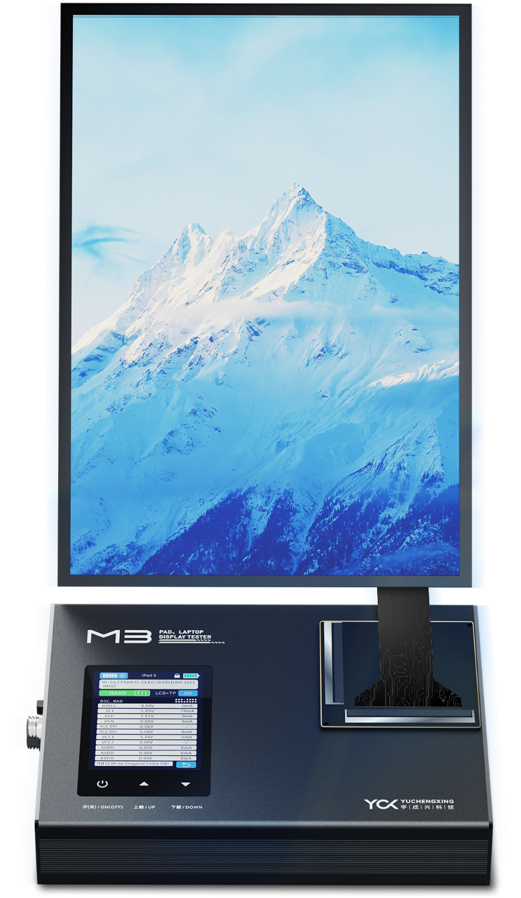

## Chapter 2 Technical Parameters Specifications

### **2.1 Hardware specifications**

|  |  |
| --- | --- |
| **Master control MCU** | ARM® Cortex®-M4 |
| **SOC** | Eight cores and eight threads CPU |
| **RAM** | 2xLPDDR4/4X_32bit (4G) |
| **ROM** | eMMC5.1 （32G) |

### **2.2 Signal specifications**

**2.21 eDP Signal specifications**

|  |  |
| --- | --- |
| **Number of interfaces** | 2 |
| **Transmission speed** | DP1.4a eDP Single channel bandwidth 8.1Gbps( MAX )  8.1G 8K/30HZ,Double interfaces 4K/60HZ,Single interface 4K/120HZ |
| **Image resolution ratio** | 3840*2160@120Hz(4lanes)7680*4320@30Hz(4lanes) |
| **Signal Lane Number** | DP1/2/4/8 Lanes and multi-screen display |
| **Dark color** | Support 6 / 8 / 10 Bits |
| **Signal assistance function** | EDID read Register reading and writing |
| **Signal ESD** | 15KV Air discharge/8KV Contact discharge |

**2.22 MIPI–DPHY Signal specifications**

|  |  |
| --- | --- |
| **Number of interfaces** | 2 |
| **Transmission speed** | The highest supported transmission rate for each channel is2.5Gbps，The Video / Command mode is supported |
| **Image resolution ratio** | Mainstream resolution support： 8k @30Hz 4k @ 60Hz |
| **Number of signal Lane** | Support for 1 / 2 / 4 / 8 Lanes |
| **Dark color** | Support 6 / 8 / 10 Bit |
| **Signal assistance function** | Register reading and writing |
| **Signal ESD** | 15KV Air discharge / 8KV Contact discharge |

**2.23 MIPI–CPHY Signal specifications**

|  |  |
| --- | --- |
| **Number of interfaces** | 2 |
| **Transmission speed** | The highest supported transmission rate for each channel is 4.5Gbps.The Video / Command mode is supported |
| **Image resolution ratio** | Mainstream resolution support：8k @30Hz, 4k @60Hz |
| **Number of signal Lane** | Support for 1 / 2 / 3 / 6 Lanes |
| **PORT** | Support 6 / 8 / 10 Bit |
| **Signal assistance function** | Register reading and writing |
| **Signal ESD** | 15KV Air discharge / 8KV Contact discharge |

**2.24 HDMI Signal specifications**

|  |  |
| --- | --- |
| **Number of interfaces** | 1 |
| **Transmission speed** | All the data rates for HDMI FRL :3,6,8,10 and 12Gbps |
| **Image resolution ratio** | Up to 7680x4320@60Hz for HDMI TX |
| **Number of signal Lane** | x1x2andx4 Configure each interface |
| **Dark color** | RGB / YUV ( up to 10bit) format for HDMITX |
| **Format** | RGB , YCbCr 4:4:4, YCbCr 4:2:2 and 8/10 bit per component video format |
| **Signal assistance function** | Register reading and writing |
| **Signal ESD** | 15KV Air discharge / 8KV Contact discharge |

**2.25 SPI/IIC Signal specifications**

|  |  |  |  |
| --- | --- | --- | --- |
| **signal**  **parameter** | **QSPI** | **SPI** | **IIC** |
| **Number of interfaces** | 1 | 2 | 2 |
| **Transmission speed** | 9M Bit/Rate adjustable | 50MHZ，Interface rate adjustable | 400K，Interface rate adjustable |
| **Data bit** | Software can be set | | |
| **Support level** | 0V/3.3V | | |
| **Signal ESD** | 15KV Air discharge / 8KV Contact discharge | | |

### 2.3 Screen power supply specification

|  |  |  |  |  |  |
| --- | --- | --- | --- | --- | --- |
| **Classification** |  | **VCC1** | **VCC2/VCC3/VCC4/ VCC5/VCC6/VCC7** | **VCC8** | **VCC9** |
| Programmable voltage parameters | Corresponding to the connection method | VBAT Large current power supply | VCC2---10V 2A  VCC3---10V 2A  VCC4---10V 2A  VCC5---10V 2A  VCC6---10V 2A  VCC7---10V 2A | VSN/ELVSS | VSN/ELVSS |
| Output voltage | 1~10V | 1~10V | -10V~-1V | -10V~-1V |
| Output current | 0~3000mA | 0~2000mA | 0~3000mA | 0~2000mA |
| Rated output power | 15W | 10W | 15W | 10W |
| Step precision | 10mV | 10mV | 10mV | 10mV |
| Voltage output accuracy | With compensation adjustment  ±20mV | With compensation adjustment  ±20mV | With compensation adjustment  ±20mV | With compensation adjustment  ±20mV |
| Ripple wave | <30mV | <30mV | <30mV | <30mV |
| Current monitoring accuracy | <100mA，±1mA ；≥100mA，±1% | | | |
| Overvoltage protection | Have | Have | Have | Have |
| Overcurrent protection | Have | Have | Have | Have |
| Remote voltage compensation | Support automatic compensation | Support automatic compensation | Support automatic compensation | Support automatic compensation |
| Dynamic load response time | <1ms | <1ms | <1ms | <1ms |
| Uptime rises along the time | <10ms | | | |
| Power drop drops along the time | <100ms | | | |
| Switch controls the reaction time | <1ms | | | |

### 2.4 Backlight power supply specifications

|  |  |
| --- | --- |
| **LED Constant flow drive specifications** | |
| LED_A Number of channels | 2 |
| LED_K Number of channels | 8 |
| Backlight voltage | 12V～50V Programmable |
| Backlight voltage accuracy | ±1V |
| Single back photocurrent range | 0～50mA Programmable |
| Single back photocurrent precision | ±0.1mA |
| Total output power | 20W |
| Total output current | 400mA |
| Overload protection | Have |
| Short-circuit protection | Have |

### 2.5 Peripheral interface

|  |  |
| --- | --- |
| **Type-C interface** | 1 |
| **USB interface(Type-A)** | 1 |
| **HDMI interface** | 1 |
| **232 serial port** | 1（Can answer the code scanning gun and lens） |
| **Expand the button interface** | 1 group（6 inputs + 2 outputs） |
| **Debug serial port UART** | 2 |
| **Burning download port** | 1 |
| **Ground rubber head** | 1 |
| **DC seat interface** | 1 |
| **Switch plate interface** | 1 group（60pin+80pin） |

### 2.6 Other parameters

|  |  |
| --- | --- |
| **Input voltage** | DC12V，4A |
| **Power switch** | Move the 2-gear switch |
| **Hot plug and pull function** | Support |
| **Module function detection** | TE Measuring range ：30HZ~500KHZ，Accuracy：±1us;  PWM Range of signal measurement ：30Hz~500KHz，Accuracy：±1us;  PWM Signal output ：30Hz~500KHz，Accuracy：±1us;  ID Level range ：0V~0.33V， Accuracy：±0.1V |
| **Anti-static standard** | Air discharge: ±15kV Contact |
| Discharge: ±8kV |
| **Alarm setting** | Each current voltage channel can be set the maximum minimum alarm value, beyond the set value can automatically power off |
| **Working condition** | Temperature ：-10℃~+70℃ |

## Chapter 3 Overall plan of equipment

### 3.1 Hardware interface

|  |  |  |  |  |  |  |  |
| --- | --- | --- | --- | --- | --- | --- | --- |
| **M3 External interface specification** | | | | | | | |
| 左边有编号 | | | | | | | |
| **M3 Side interface diagram (left)** | | | | | | | |
| **1** | **Ground socket** | **2** | **DC_12V power input** | **3** | **Power switch** | **4** | **232 serial port（Selective equipped ）** |
| **5** | **SWD download** | **6** | **UART Debug test** | **7** | **Key extension port** | **8** |  |
|  | | | | | | | |
| **右边有编号** | | | | | | | |
| **M3 Side interface diagram (right)** | | | | | | | |
| **1** |  | **2** | **Headphone seat** | **3** | **TYPE-C Communication mouth** | **4** | **HDMI Output interface** |
| **5** | **USB interface** | **6** | **K3 Toggle the video / picture** | **7** | **K2** | **8** | **K1 Program recommendation** |
|  |  |  |  |  |  |  |  |
| **8** | | | | | | | |
| **M3 Top surface interface diagram** | | | | | | | |
| **1** | **2.8-inch display (with touch function) 320 * 240 resolution** | **2** | **Module power switch** | **3** | **Press (turn up) Picture to pause / play when it is automatically played** | **4** | **Press the button (turn down) Pause / play when the picture plays automatically** |
| **5** | **60Pin Power output seat** | **6** | **80Pin Signal loss**  **Out of the seat** | **7** |  | **8** |  |

### 3.2 Outline dimension

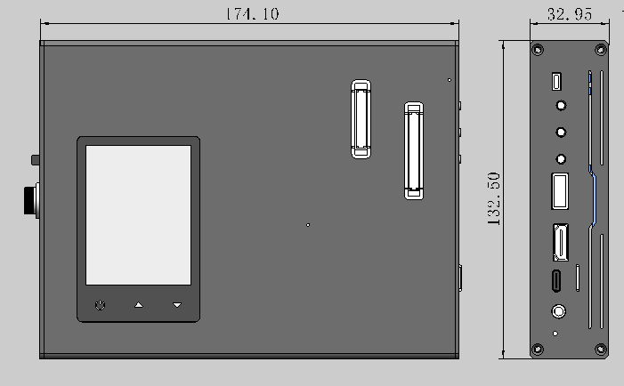

## Chapter 4 Specification for the use of equipment

### 4.1 Matters need attention

**4.11 Earthing line confirmation**

M3 LCD module analyzer is a high precision electronic testing equipment. Please install the grounding wire synchronously to ensure that the equipment and the supporting shell are connected with the earth or equivalent ground supply equipment.

**4.12 Other matters needing attention**

* This equipment shall not be installed in a dusty or very wet environment to reduce the service life and damage of the equipment;
* The use environment of the equipment should be as ventilated as possible to ensure the effective heat dissipation of the equipment;
* The input and output interface of the equipment is clearly identified and standardized, and do not connect the wrong interface or the positive or negative electrode of the power supply during use;
* Do not disassemble the equipment to avoid injury by internal circuit or equipment damage;
* Please clean the dust and other foreign bodies accumulated by long-term use in the equipment regularly and keep the equipment clean.

### 4.2 Frequently asked questions

* **Problem 1：Current and voltage overload protection**

Ensure correct wiring, reconfigure voltage and current protection card control value, and restart PG test.

* **Problem 2：The backlight of the dot screen module is not lit**

Check that the wiring is correct and the backcurrent voltage is set correctly.

Confirm whether the signal wire connecting the PG and the test module matches the test module;

If the signal wires are correct, confirm whether the configuration of VDD, Timing, clock frequency, and screen opening instructions match the test module, and whether the VDD power supply O / UVP and O / UCP settings meet the test module specifications